FACULTY MENTOR HANDBOOK

College Now
SMSU COLLEGE NOW PROGRAM:
Southwest Minnesota State University has offered concurrent enrollment courses since 1984-85, hosting the longest continually running concurrent enrollment program in Minnesota. The program strives to grow, develop, and transform to meet the needs and standards set forth around concurrent enrollment. Our educational philosophy is that mentorship, collaboration, professional development, and curriculum combine to create the college academic classroom in the high school. That is our goal every day. We are focused and passionate about bridging the gap from high school to college for our students.

PROGRAM BENEFITS:
- Allows students to earn college and high school credit simultaneously
- Provides transition and introduction to university study and procedures
- Offers advanced-learning opportunities for motivated students
- Concludes with a college grade on a college transcript
- Allows for more flexible scheduling upon enrollment at the university
- Can accelerate student degree completion; therefore lowering the overall expense of college
- Inspire increasing numbers of high school students to attend college
- Promotes student self-confidence
- Strengthens relationships between high schools and SMSU

FACULTY MENTORSHIP PHILOSOPHY:
Mentoring is a partnership between two people that supports a professional and personal development approach in which an experienced person assists another in developing skills and knowledge. A mentor gives advice, encouragement, support, and leads by example through his/her expertise in a subject, skill, departmental, and institutional knowledge. A mentor’s focus goes beyond learning specific competencies or tasks and builds a climate of trust so the mentee can feel secure to seek advice on issues influencing their success.

FACULTY MENTOR ASSIGNMENTS:
Academic support is provided to high school instructors through the corresponding department at Southwest Minnesota State University. Each high school instructor is provided with a department faculty mentor that helps with all needs in relation to teaching a college course. High school teachers are expected to interact with their mentor and implement mutually agreed upon instruction within their College Now courses.

Each year the College Now staff will send a list of requested dual credit courses to the respective department chair. The department chair will assign a faculty mentor to work with each high school instructor to provide curriculum and instructor support. At the beginning of each semester, the College Now program will send faculty mentors a listing of the high school courses and instructors they will oversee for the upcoming semester.

In order to ensure the integrity of courses offered through the College Now program, and to meet accreditation standards, SMSU has adopted the below list of faculty responsibilities. The “College Now Course Checklist for Faculty Mentors” form (Appendix A), submitted by the faculty mentors at the end of the course, provides documentation that SMSU has demonstrated appropriate oversight of the College Now course offered in the high school.
FACULTY MENTOR RESPONSIBILITIES:
Given the College Faculty Mentor will monitor the delivery of his/her institution's course at the high school setting, the College Faculty Mentor will assume the following responsibilities:

Concurrent Enrollment Instructor Support:
- Share with College Now staff the departmental requirements regarding course textbooks or updates by the first week in December for the following school year.

- Notify the College Now Office and high school teachers as soon as possible regarding any course syllabi updates, changes in curriculum, and when new textbooks are selected.

- Provide access to exams, sample work, and other supplementary materials approved by the department for use with the specific courses delivered at the high school. The College Now Office does recognize that this is the intellectual property of the faculty. If a sample is not provided, mentors should provide guidance to the high school instructors as they develop the necessary materials.

- Assist high school instructors /school districts in selecting department approved textbooks.

- Be available to the high school instructor throughout the duration of the course to provide guidance about the content and structure of the course.

- Be available to give presentations of discipline-specific lectures when requested.

- Collaborate with the College Now staff and act as a liaison with the high school instructor to resolve questions and concerns that may arise within the course.

Professional Development:
- Deliver annual, discipline-specific Professional Development and New Teacher Orientation workshops for high school instructors. Complete meeting agenda and tracking forms (Appendix B and C) for each session of the annual workshops. Agenda and forms should be submitted to the College Now Office for tracking and accreditation purposes.

- For a new course, meet with the high school instructor before the beginning of the course to ensure that the high school course is equivalent to that offered on-campus at SMSU. Mentors will discuss course syllabi and provide supplemental materials, sample work, sample exams, etc. or help in the development of these items.

- For a repeat course, contact the high school instructor (in-person, e-mail, phone, or video communications) within three weeks of the start of the course to ensure that previously agreed upon course outcomes, syllabi, supplementary materials, textbook, exams, etc. are still viable.

Communication:
- Request and approve course syllabi. Syllabi should be saved within the department for each College Now course every year, as many times students will request a syllabus when attempting to transfer credits after graduation.

- Communicate with the high school instructor through phone, e-mail, video communications, or in person at least three times before the end of the course (start of course, mid-semester, and prior to final exam is recommended).

- Establish communication expectations/timeline with each high school instructor. Although not required, monthly networking sessions are appreciated by many high school instructors.

- Discussions should cover areas of course content and materials, delivery, evaluation methods, students' success in meeting learning outcomes, and assessment instruments used to ensure that course outcomes are measured accurately.

- Remind high school teachers to verify eligibility of the students and the accuracy of their rosters. Although not required, it may be helpful to utilize a D2L assignment to catch any missing registrations.

- Help resolve any questions about accommodations for identified students with disabilities.

Site Visits:
- For a new class, visit at least one class session on site at a mutually agreeable time prior to mid-semester.

- For a repeat class, visit at least one class session at a time deemed appropriate by the partners.

- Site visits should be on-site for all first year courses and on-site at least every other year following the initial visit for returning courses. Any variations from this requirement will need approval from both the Director of Concurrent Enrollment and the Dean. (**Although only required every other year for repeat courses, it is strongly encouraged and even recommended to conduct one on-site visit every year, for every course when possible as this helps students associate their credits with SMSU, as well as helps with recruitment efforts.)

- In each instance above, the faculty mentor should inform the class of the significance of the course in the college curriculum. Faculty can also discuss the college experience as a whole with the high school students. The SMSU Admission Office will provide talking points that should be used during classroom visits.

- Submit a “Classroom Visit” form (Appendix D) for every class within three weeks of the classroom visit.

- Alert the College Now Office to any concerns regarding high school instructors or course content.

- Submit an expense report for reimbursement to the College Now Office to receive compensation for travel expenses. Any employee expense report that is not fully completed will not be submitted until completed appropriately. Reports must be submitted within two months of the visit date or they will be subject to tax withholdings. All expenses must be submitted by June 30th of that academic year.

- If an additional on-site visit is required for a course, the College Now Director must approve the additional visit.
Assessments, Grades, and Documents:
- Be actively involved in student outcome assessments. Mentors need to review at least one set of graded course equivalent assessments or work samples to ensure academic rigor and grade equivalency to SMSU on-campus courses.

- Provide guidance on grading policies used within on-campus classrooms/departments at SMSU.

- Remind high school instructors about end of course surveys. Students need to complete a “Student Satisfaction Survey” for each College Now course completed. Surveys should be completed within the final two weeks of a course. Results will be shared with the faculty mentor and high school instructor.

End of Course Responsibilities:
- Submission of suggested grades from high school instructors to their faculty mentor should happen within one week of the course end date listed in the system. Faculty mentors then have an additional two weeks to review submitted grades, course materials, etc and enter final grades into the system.

- Submit final grades using the online grade entry system.

- All grades should be submitted no later than June 30th of that academic year.

- Follow-up on any discrepancies between the course roster and the submitted grades for a course. Mentors should reach out to the high school teacher first and copy the College Now Assistant Director to inquire about the discrepancies.

- Submit to the College Now Director the “College Now Course Checklist for Faculty Mentors” (Appendix A) showing date and mode of communication for the following:

- Initial contact with the high school instructor to review syllabus and other course materials.

- Contact with the high school instructor to verify eligibility status of students and enrollment in the course. Help resolve any questions about accommodations for identified students with disabilities.

- Two additional communications with the high school instructor (in person, via e-mail, phone, or video-conference) to monitor course progress

- Classroom visit date (can count as one of the additional communications efforts)

- Completion of expense report for on-site visit (if applicable)

- Review of end of course assessments/grades and posting of final grades

COMPENSATION:
- Faculty Mentors will be compensated at .58 load for each returning high school course they collaborate on. Mentors will be compensated at .66 load for any new high school course offerings they collaborate on.

- Multiple sections of the same course at a high school will be treated as one course, unless the high school instructor changes or the start/end dates differ.

PROFESSIONAL DEVELOPMENT EXPECTATIONS AND REPORTING:
- Mentoring for College Now is part of faculty workload and considered a reporting item under Criterion One “Demonstrated ability to teach effectively and/or perform effectively in other current assignments” in the Professional Development Plan (PDP) and Report (PDR).

- The Academic Deans will expect that the responsibilities and outcomes listed in this Faculty Mentor Handbook are accounted for as such in the PDP and PDR.

- The “College Now Course Checklist for Faculty Mentors” can be used for documentation in the PDR, along with other materials if desired.

- If faculty acting in a mentor capacity are not meeting these responsibilities to demonstrate minimum effectiveness, they will be assigned to other courses or roles.

COLLEGE NOW OFFICE STAFF:

Jessica Mensink
Director of Concurrent Enrollment
BA 264
(507) 537-6390
Jessica.Mensink@SMSU.edu

Ellie Ahmann
Assistant Director of College Now
BA 266
(507) 537-6138
Ellie.Ahmann@smsu.edu

Appendix A
Course Checklist for Faculty Mentors

(a blank copy available at www.smsu.edu/academics/collegenow/mentoringfacultyresources/index.html)

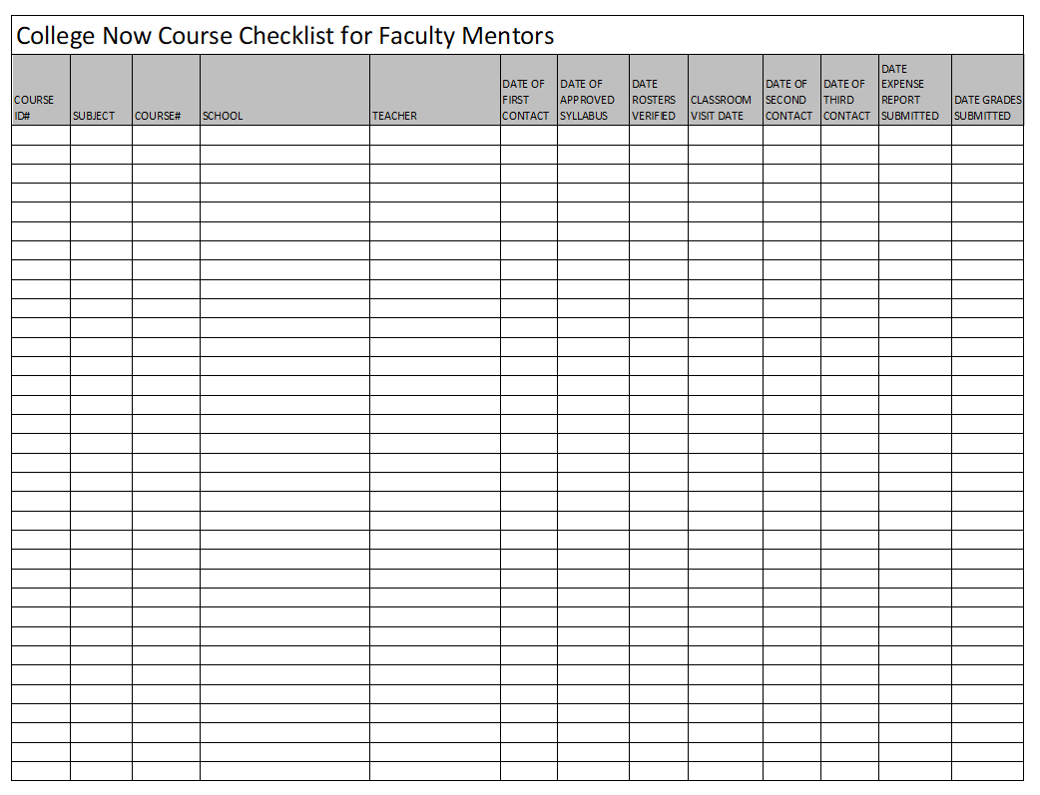

Appendix B
New Teacher Orientation Workshop Tracking Form
(copy available at www.smsu.edu/academics/collegenow/mentoringfacultyresources/index.html)

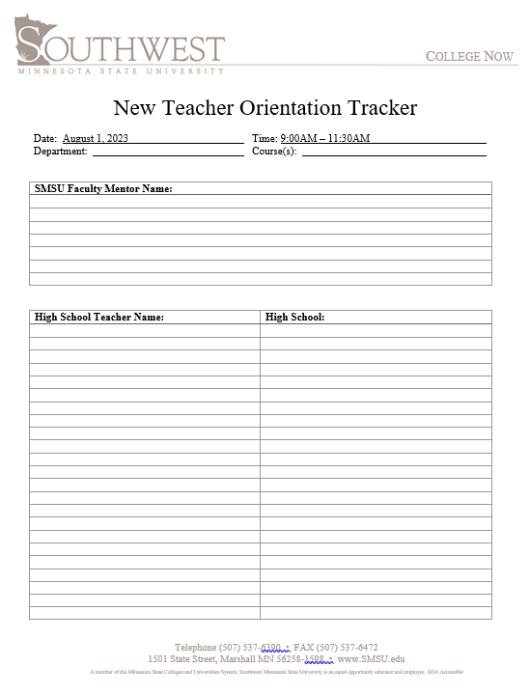

Appendix C
Professional Development Workshop Tracking Form
(copy available at www.smsu.edu/academics/collegenow/mentoringfacultyresources/index.html)

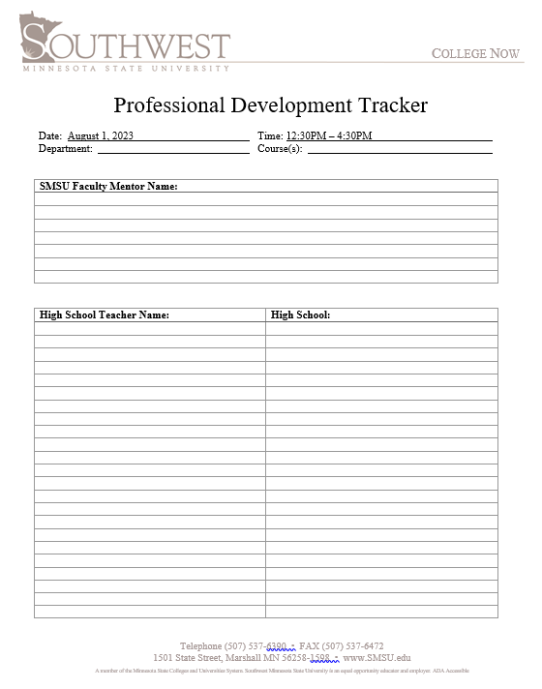
Appendix D
Classroom Visit Form

(completed electronically at https://forms.office.com/r/A9xE2JxvGJ)

Visual of this form will be coming soon…

