"A Festival of Woodwinds" Application

Contact Information:

Name:

Street Address:

City: State: Zip:

Email:

Registration Type:

Please check next to the type of registration you would like to submit:

Early Registration (individual) $30
Must be postmarked/sent by January 21, 2022

Normal Registration (individual) $40

Part of a school group attending TBD
Paid as a group by the director (director should contact Dr. Ginocchio for group rates)

**Note: The Finale Concert is free and open to the public.

Instrument:

Primary woodwind instrument you play:

Years you have played: Private study? (circle) Yes / No How long?:

if yes, name of teacher(s):

Check next to the experiences you have had in playing this instrument:

Middle School Band High School Band College Band

Community Band Honor Band All-State Band

Solo & Ensemble (which? solo and/or ensemble)

Other, non-school groups in which you have played (please list below)

Other solo performances you have done (please list below)

(please continue on the next page)

Please circle the number that you believe represents you current ability level on this instrument.

Beginner---------------Intermediate----------------Advanced---------------Professional

1 2 3 4 5 6 7 8 9 10

On the staff below, please provide the lowest and highest notes that you feel comfortable playing on your instrument.
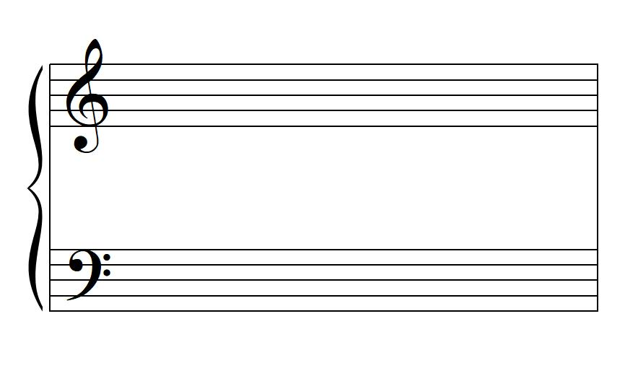
Do you play any other woodwind instruments?

School Information (if you are in school):

School Attending:

Band Director:

Grade in School:

Lunch Information (if planning to attend the whole day):

Please list any dietary restrictions or allergies I need to know to plan lunch for you.
Lunch is included in the individual and school registration costs.

Please print, complete, and send along with payment to:

"A Festival of Woodwinds"
c/o Dr. John Ginocchio
SMSU Bands
1501 State Street
Marshall, MN 56258

Checks should be made out to SMSU Bands.

