Contents

Introduction 1

Login 2

Reviewing Submitted Leave Requests 2

Manage Request – Filter your results 3

Submit a Personal Leave Request 3

Submit a Leave Request 5

Edit a Leave Request 6

Delete a Leave Request 6

View Balances 7

Timesheet 7

Update or Submit a Timesheet 7

Edit a Timesheet 8

Timesheet Messaging 9

Exempt Employee Time Reporting 9

Employee Pay Details 11

Pay Details Report 11

State Self Service 11

Log Out 11

Additional Documentation 11

Need Help? 11

Introduction

The Time and Leave Reporting application provides MSUAASF employees access to their leave requests as well as leave balances and activity. Within the Time and Leave Reporting application, the Employee Pay Details section allows an employee to view Pay Details for the current or prior fiscal years where there were payments scheduled and made. If a MSUAASF employee is a supervisor, please review the Supervisor User Guide for additional navigation and instruction.

Login

1. On the Minnesota State Login screen, enter your Star ID and password
2. Click Login.
3. The Time and Leave Reporting application will display. If you land on the Employee Home page after logging in, go to the ***eTimesheet*** option.

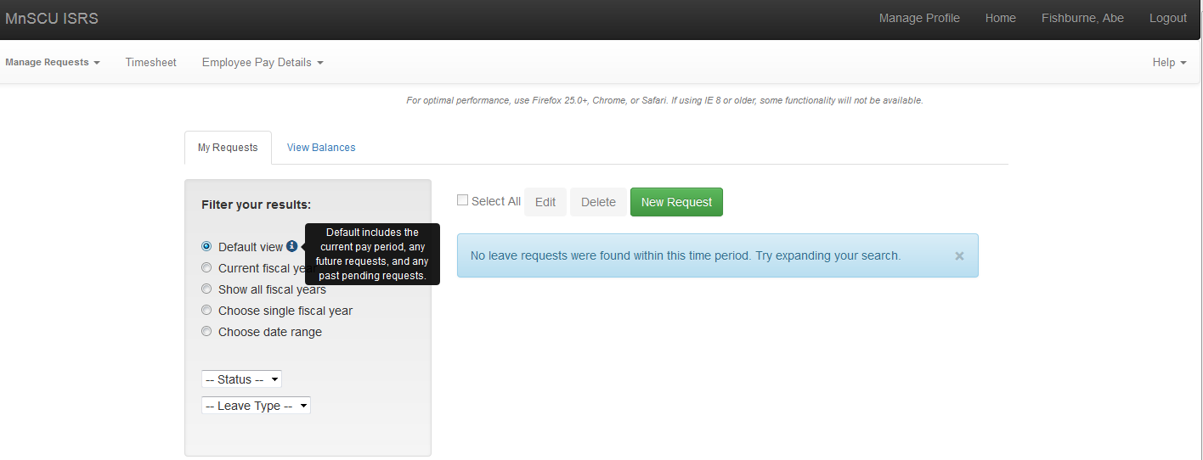

NOTE: In the top navigation bar, there is a link to Timesheet reporting, which would apply to employees who complete a timesheet and supervisors who approve timesheets for employees.

If you click on Timesheet Reporting in error, just use your browser Back button, or click on the Manage Requests tab to return to the My Requests page.

Reviewing Submitted Leave Requests

The Manage Requests screen provides a list of submitted requests. The default view of leave requests includes the current pay period, any future leave or overtime requests, and any past requests that are in a Pending status. If there are not requests that meet that criteria, the message “No leave requests were found within this time period. Try expanding your search.” will be displayed.

When requests are displayed, the status, leave type, amount in hours or days, and date of request are included in the list. Additional details for each request can be viewed by clicking on the More icon on the right of each request. Additional information includes the start and end time, created by, date created, and any comments that may have been entered for the request. Newly created requests are highlighted in Blue.

Manage Request – Filter your results

There are a number of options for viewing your request history, or to search for requests for a particular status or leave type. The default view of leave requests includes the current pay period, any future leave or overtime requests, and any past requests that are in a Pending status. (For information about statuses, see the ***Leave Request Statuses*** document under **Additional Documentation** below.)

* Current fiscal year: To see all leave requests for the current fiscal year (First day of the first pay period that ends in the new Fiscal year through the last day of the last pay period in the fiscal year), click on the *Current fiscal year* button under **Filter your results**.
* Show all fiscal years: To see leave requests for all fiscal years click on the *Show all fiscal years* button under **Filter your results**.
* Choose single fiscal year: To see all leave requests for a specific fiscal year (July 1st to June 30th), click on the *Single fiscal year* button under **Filter your results** and choose the fiscal year from the dropdown.  
  Note: Only fiscal years where requests exist will show up in the Fiscal Year dropdown
* Choose date range: To see all leave requests for a specific time period, click on the *Choose Date Range* button under **Filter your results** and enter a *From:* date, or pick one from the calendar presented, then enter a *To:* date, or pick one from the calendar, then click on the **set dates** button
* Status:Leave requests may be viewed by status by clicking on the *Status* dropdown box.
* Leave Type:To see all leave requests for a specific leave type, click on the *Leave Type* dropdown box.

Submit a Personal Leave Request

MSUAASF employees normally request time off in hours, but personal days have specific rules according to the bargaining agreement:

* Personal days are taken as full days.
* MSUAASF employees are allowed to take up to four days of personal leave per fiscal year.
* MSUAASF employees may take personal leave on consecutive days only with approval from their President or their President’s designee.

1. On the Minnesota State Login screen, enter your Star ID and password. Click Login.
2. The Time and Leave Reporting application will display.
3. Click on the green *New Request* button 
4. A Create Request screen will appear.

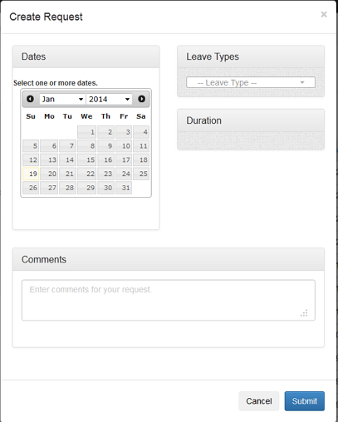

1. **Dates:** Select one or more dates on the calendar by clicking in the date. A date or dates must be selected before you can choose Leave Types or Duration. In the Month/Year header you may choose dates in the past or future by clicking on the arrows, or choose from the dropdown to change the month or year.

**Note:** Selected dates will appear below the calendar. If you choose a date in error, click on it again to inactivate that date.

1. **Leave Types:** Select Personal Leave from the drop-down menu. The Leave Type list will only display leave types that you are eligible to use.
2. **Duration:** The default is for a full day of leave.
3. **Comments:** Enter Reasons/Comments if desired. Comments are required if the request is for a date more than two pay periods in the past.
4. Click *Submit*.

NOTE: If more than 4 days of personal leave are requested in a Fiscal year, the following error message will display:

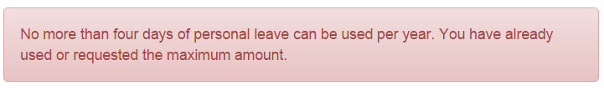

Contact your campus Human Resources office if there are any questions or you have a special approval by the President of your institution.

Submit a Leave Request

1. On the Minnesota State Login screen, enter your Star ID and password. Click Login.
2. The Time and Leave Reporting application will display.
3. Click on the green New Request button 
4. A Create Request screen will appear.



1. **Dates:** Select one or more dates on the calendar by clicking in the date. A date or dates must be selected before you can choose Leave Types or Duration. In the Month/Year header you may choose dates in the past or future by clicking on the arrows, or choose from the dropdown to change the month or year.

Note: If you choose a date in error, click on it again to inactivate that date.

1. **Leave Types:** Select a Leave Type from the drop-down menu. The Leave Type list will only display leave or additional pay types that you are eligible to choose.

Note: If you select Sick Leave for a type, you must select a Sub Type.

1. **Duration:** Enter the Begin Time and the End Time. Select am or pm. The default is 8:00 am to 4:30 pm, and the system assumes a 30 minute lunch period. You may change any of these values to reflect the actual leave duration.
2. **Comments:** Enter Reasons/Comments if desired. Comments are required if the request is for a date more than two pay periods in the past, if Sick Leave (SIK) is used with the Sub Type of Bereavement, or , or if Bereavement (BRV) that is not deducted from sick leave.
3. Click Submit.

Edit a Leave Request

Leave requests can be edited if the status of the request is Pending, Approved or Processed.

1. On the Minnesota State Login screen, enter your Star ID and password. Click Login.
2. The Time and Leave Reporting application will display.
3. Choose the request you would like to edit and click on checkbox to the left of the item.
4. Click on the blue *Edit* button, which is activated when a checkbox is indicated.
5. You may then edit the start or end time, total hours per day, or the comments.

**NOTE:** To change the leave type or date, you must delete the request and recreate it with the correct leave type and date.

Delete a Leave Request

You may delete a request if the status of the request is Pending Approved or Processed.

1. On the Minnesota State Login screen, enter your Star ID and password. Click *Login*. The Time and Leave Reporting application will display.
2. Choose the request(s) you would like to delete and click on checkbox to the left of the item(s).
3. Click on the Red *Delete* button.
4. An alert box will appear to confirm that you are going to delete the indicated number of requests. To complete the delete process, click on the *Confirm Delete* button.

View Balances

MSUAASF leave balances and leave history can be reviewed by going to the View Balances tab in Time and Leave Reporting. Click on the More icon for each leave type to review leave activity.

**Note:** some balances may appear in days, and some balances are in hours.

Leave balances and activity will be displayed for any current or previous leave eligible teaching or administrative job at any Minnesota State institution. If there are multiple institutions, they will display in alphabetical order by institution.

If there has been activity (leave earned, used or adjusted) within the last year for a leave type, it will be displayed, even though the balance may be zero. In some instances the balance may appear as a negative amount.

Questions regarding leave balances and activity should be directed to your campus HR/Payroll Office for review.

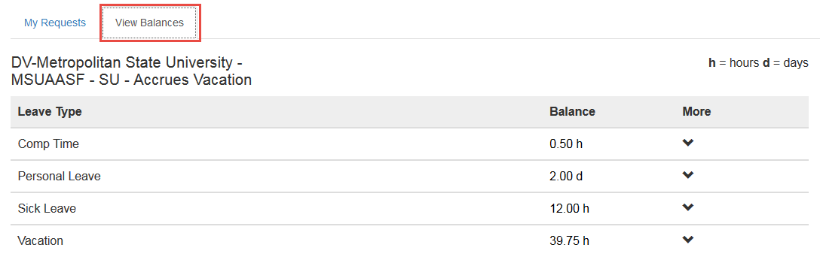

Timesheet

Update or Submit a Timesheet

A non-exempt MSUAASF employee will complete the following steps to update or submit a timesheet. Please submit any leave or additional pay/overtime requests before submitting your timesheet. If you are not available to submit your timesheet, and it is due to Payroll, your supervisor may submit the timesheet for you.

NOTE: Once your supervisor has approved your timesheet, any additional leave or OT requests may require that you adjust your timesheet. See **Edit Timesheet** for more information.

1. On the MnSCU Login screen, enter your Star ID and password. Click *Login*.
2. The Time and Leave Reporting application will display. Click on the *Timesheet* link in the top navigation bar. If you have more than one position, select the one you want to update or submit.
3. The *Employee Home* screen will then display.

**NOTE:** The Pay Period Ending date defaults to the end date of the current pay period. You can select a different date from the drop-down list in the left navigation menu.

1. The default timesheet for the current pay period is displayed. The hours are calculated by the system based on your work schedule, holidays, and leave requests for the pay period. The hours listed are for your specific schedule and may include:

• Regular hours

• Holiday pay

Total Hours for the pay period is the sum of regular hours, holiday hours and leave or overtime requests.

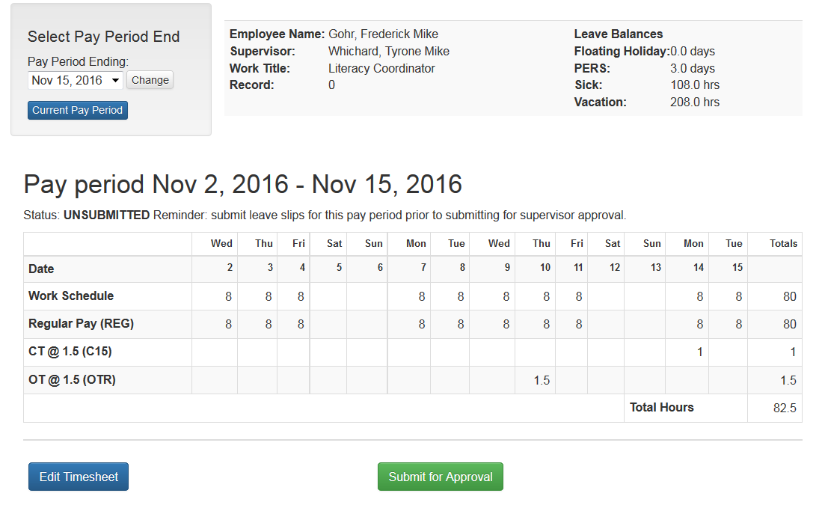

1. If the default timesheet is correct as shown, click *Submit for Approval*. The timesheet status is then changed to Submitted and will be available to your supervisor for review and approval.

Edit a Timesheet

Employees or their supervisors may need to edit a timesheet if an employee’s schedule has changed, or if a leave or additional pay request is entered after the supervisor has approved the timesheet. If this occurs, a notice will be presented on the timesheet screen. Below are the steps to edit a timesheet.

1. To make changes to the timesheet, click *Edit Timesheet*. The *Update Timesheet* screen will then display.
2. You may edit regular hours, shift differential hours, and holiday hours if applicable.

* Leave requests or additional pay requests can only be changed by creating, modifying or deleting a request on the *Manage Requests* page.
* Shift differential hours cannot be greater than regular hours plus overtime hours, and cannot be added to a day when none were scheduled.

1. Make the desired changes, add any comments and select *Save Timesheet*.
2. You will then be brought back to the timesheet, where the notice will indicate the *Timesheet has been updated.*
3. To submit the timesheet for your supervisor’s approval, click *Submit for Approval*. This will save your changes, and submit your timesheet for your supervisor’s approval.

Timesheet Messaging

The following messages may be presented when completing your timesheet. These are warning messages to help you ensure your time reporting is accurate; however you may still submit the timesheet.

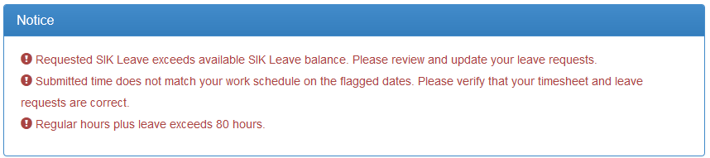

• If you have requested more leave in the current pay period than you have available, you will receive the message similar to this example: “Requested VAC Leave exceeds available VAC Leave balance. Please review and update your leave requests.” This message will display for Sick Leave, Vacation or Compensatory Time.

* Total of leave plus regular hours doesn’t match the employee’s work schedule. This shows whether the reported hours are greater or less than the scheduled hours.

If the time you submitted does not match your work schedule, the days that don’t match will be marked with a red flag. You will receive the message: “Warning: Submitted time does not match your work schedule on the flagged dates. Please verify that your timesheet and leave requests are correct.”

• If Regular, Holiday and Leave hours total more than 80 hours, a warning message will display to allow you an opportunity to correct the hours. You may still submit the timesheet.

Exempt Employee Time Reporting

An MSUAASF employee who has an FLSA status of Exempt will submit requests for leave, but not a full timesheet. If you have leave requests for the pay period, you should submit them prior to submitting the timesheet. If you are not available to submit your time reporting, and it is due to Payroll, your supervisor may submit time reporting for you.

**Note:** An exempt part time employee will NOT be able to make any changes to their timesheet. Part-time exempt employees will no longer have the ability to view or edit their hours in eTime. Part-time exempt employee work schedules are maintained by Human Resources, and supervisors and payroll are the only ones who can view/edit the hours.

1. Go to the *Timesheet* link in the top gray navigation bar.
2. If you have more than one position, select the one you want to update or submit.
3. Your Timesheet page will display a calendar grid for the pay period that will list your requests.
4. If you have no requests for the current pay period, you will see the message: “There are no requests for this pay period” on the bottom of the page.

**NOTE**: You can choose a different pay period, past or future, to work with by changing the *Pay Period Ending* in the *Select Pay Period End* section, and then click on the *Change* button.

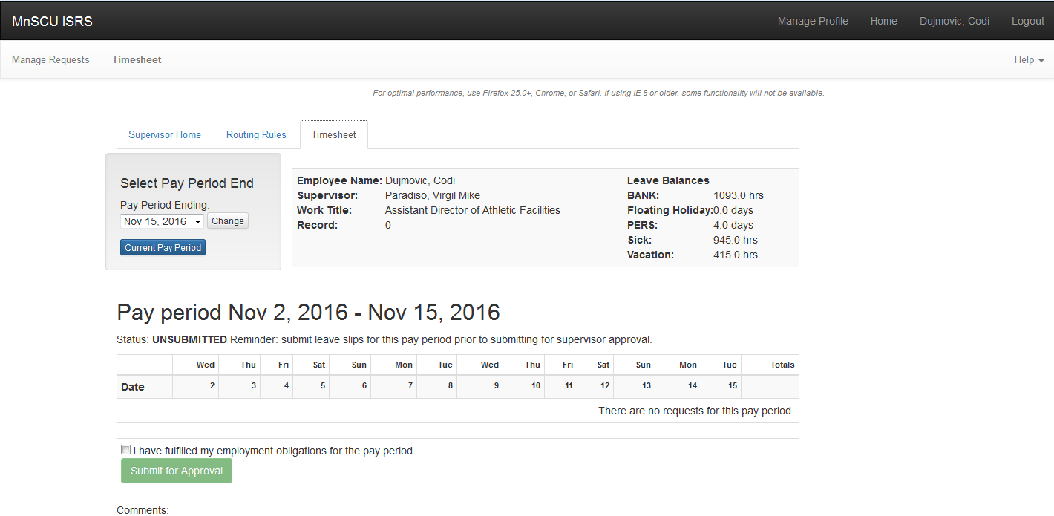

1. To add comments about your time reporting, click the *Enter New Comments* (max 500 characters) link. A comment box will appear below. After you have finished typing your comments, click *Save Comments*.
2. If you have no requests for the pay period, or you have finished submitting your requests, click the checkbox next to the statement “I have fulfilled my employment obligations for the pay period”.
3. Click *Submit for Approval* to submit your time reporting to your supervisor for approval. The status for the pay period is updated to Submitted.

**NOTES:**

* Even if you have no requests, you must acknowledge that you have fulfilled your work obligation for the pay period.
* The “Submit for Approval” button will not be active until you check the box above it.
* If you create a new request, or edit or delete a request, your time reporting will go back to an Unsubmitted status and you will need to again submit the timesheet to your supervisor for approval.

Employee Pay Details

There are two options available under the ***Employee Pay Details*** tab, either the Pay Details Report or Employee State Self Service.

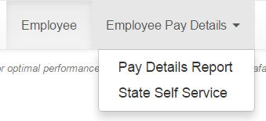

Pay Details Report

You may choose the Pay Details Report option that will allow you to generate a Pay Details report. The Employee Pay Details report provides an employee with information by pay period and check date of scheduled pay and what was actually paid (Pay Check) across all institutions. The report shows totals by pay period and keeps a calculated balance each pay period using Assn Dollars total from Assignment Summary section minus Paid FYTD amount from Check Details.

State Self Service

To go to State of Minnesota State Self Service site where your pay stub and W-2 are located, click on the State Self Service option. You will need your State of Minnesota ID and password to access this site. Contact your campus Human Resources office for this information.

Log Out

To log out of Time and Leave Reporting, click on *Logout* in the top right of the screen.

Additional Documentation

Need Help?

For additional assistance, please submit a ticket via the Minnesota State IT Service Desk portal: [https://servicedesk.mnscu.edu](https://servicedesk.mnscu.edu/)

The Minnesota State Colleges and Universities system is an Equal Opportunity employer and educator.