SMSU Center for International Education (CIE)  
***Global Express***Vol 02 Issue 01 | ***August 31, 2020***

cid:image004.png@01D67FC4.6416C620

Welcome Back All SMSU Students!

Hope you all had a great Summer! New Name – New Look! Please stop by the office between **12:30 - 4:30 PM on Tuesdays, Wednesdays, or Thursdays** – if you can tell us our new office name you get a small goodie bag. Limited quantities - first come, first serve.

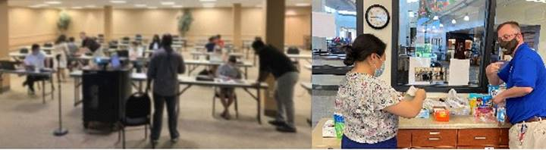

*Michael and Dr. May Lee preparing goodie bags for new students*

Recap of MISO

Mandatory International Student Orientation with social distancing

SMSU welcomes 12 new students this Fall 2020 semester from Ethiopia, Taiwan, Rwanda, Nigeria, Australia, Nigeria, Pakistan, France, and Ireland. The ISO Club started a new tradition of organizing a Tour of Marshall town for the new students, making quick stops at iconic landmarks like Camden Park, Independence Park, Downtown Marshall, and the Lyon County Museum.

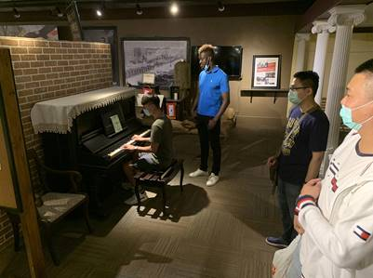

*International students Lyon County Museum tour*

ISO Opportunities

**International Student Organization (ISO) is also looking for new board members this semester. ALL POSITIONS ARE OPEN!** Look out for an email regarding positions and procedure to apply. We are looking for new ideas and opportunities for club activities in this time of COVID. We want your feedback! Don’t hesitate to send us your thoughts and ideas.

 > [Join ISO Club](https://nam02.safelinks.protection.outlook.com/?url=https%3A%2F%2Fsouthwestmsu.campuslabs.com%2Fengage%2Forganization%2Finternationalstudentorganization&data=02%7C01%7Cmaylee.moua-vue%40smsu.edu%7C1ae8d17f27bb41c4d0e608d84e0571c9%7C5011c7c60ab446ab9ef4fae74a921a7f%7C0%7C0%7C637345132620452890&sdata=niPjdiajS6lHZbsUAeSeiUG8AvVyyAE1Pg8C5H77l7Q%3D&reserved=0)

**Career Tips - Work in the U.S. on Internships & Summer Jobs**

Curricular Practical Training (CPT) allows you to work off campus while you are a student and earn academic credit for it. It’s perfect for internships and summer jobs.

**CPT & Career Planning Workshop - THUR | Sept 10 | 3:00 – 4:00pm**

> [Register](https://nam02.safelinks.protection.outlook.com/?url=https%3A%2F%2Fminnstate.zoom.us%2Fmeeting%2Fregister%2FtJwrceisqzIsGt3YpCjpmjLq-G3cV3x7CR8L&data=02%7C01%7Cmaylee.moua-vue%40smsu.edu%7C1ae8d17f27bb41c4d0e608d84e0571c9%7C5011c7c60ab446ab9ef4fae74a921a7f%7C0%7C0%7C637345132620452890&sdata=lr9%2F5mC3fNpMNbWg8xJa3X8gKdpbT5WfuwYwtq4ywcQ%3D&reserved=0) (Zoom invite)

**Are you Graduating this December? Apply for OPT Now.**

Optional Practical Training (OPT) allows you to work anywhere in the U.S. in a job *related* to your major field of study *after* you graduate. This workshop is mandatory before you can apply. The application approval process takes 3-5 months. OPT fees will increase from $410 to $550 if mailed after Oct 02. Do not wait, apply now to save money.

**Zoom OPT Workshop - FRI | Sept 11 | 3:00 – 4:30pm**

> [Register](https://nam02.safelinks.protection.outlook.com/?url=https%3A%2F%2Fminnstate.zoom.us%2Fmeeting%2Fregister%2FtJAsdOiuqD0oE9zs5FZafyg37ZsUGASh0lU5&data=02%7C01%7Cmaylee.moua-vue%40smsu.edu%7C1ae8d17f27bb41c4d0e608d84e0571c9%7C5011c7c60ab446ab9ef4fae74a921a7f%7C0%7C0%7C637345132620462884&sdata=ZD2%2FuIwvHLfoi8g70T2rucEb4CtzgNjDatdK9gpU45E%3D&reserved=0) (Zoom invite)

cid:image004.png@01D67FC4.6416C620

H E A L T H

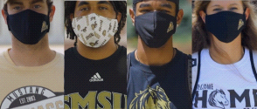

SMSU Mask Policy & COVID Self-Assessment

Southwest Minnesota State students are required to wear masks on campus. This is for everyone's safety as COVID is alarmingly contagious. Don't forget to fill out the COVID-19 self-Assessment forms daily: [https://mnscu.co1.qualtrics.com/jfe/form/SV_0oA2XakMFIL284Z](https://nam02.safelinks.protection.outlook.com/?url=https%3A%2F%2Fmnscu.co1.qualtrics.com%2Fjfe%2Fform%2FSV_0oA2XakMFIL284Z&data=02%7C01%7Cmaylee.moua-vue%40smsu.edu%7C1ae8d17f27bb41c4d0e608d84e0571c9%7C5011c7c60ab446ab9ef4fae74a921a7f%7C0%7C0%7C637345132620462884&sdata=UGikqNOb%2FDVOtyE7728x%2FQZvmLp%2B4k7ScfWIdrdMDU8%3D&reserved=0)

cid:image004.png@01D67FC4.6416C620

**Joke of the Day:**

**Hear about the new restaurant called Karma?**

**There’s no menu: You get what you deserve.**

**cid:image004.png@01D67FC4.6416C620**

**Next issue:** Volume 2 Issue 02 will arrive in September. We wish you all the best in your academic endeavors.

Image

A publication of the SMSU [Center for International Education](https://nam02.safelinks.protection.outlook.com/?url=https%3A%2F%2Fwww.smsu.edu%2Fadmission%2Finternational%2Findex.html&data=02%7C01%7Cmaylee.moua-vue%40smsu.edu%7C1ae8d17f27bb41c4d0e608d84e0571c9%7C5011c7c60ab446ab9ef4fae74a921a7f%7C0%7C0%7C637345132620472879&sdata=RsjiEO9uGrxKmxNMSyXgpDj9netDuA0OJ%2Fdh7KJJ%2Bbo%3D&reserved=0)

Student Center, Room 237  
[1501 State Street, Marshall, MN 56258](webextlink://1501%20State%20Street,%20Marshall,%20MN%2056258/)

**CENTER FOR INTERNATIONAL EDUCATION**

**OFFICE HOURS**

Mondays - Fridays, 8:30am - 4:30pm

Walk-In Advising available Mondays - Thursdays, 12:00pm-4:00pm.

Visit, Call, or Email us during our Office Hours.

Phone:  (507) 537-6018

Email:  [CIE@smsu.edu](mailto:CIE@smsu.edu)

