SMSU Center for International Education (CIE)   
***Global Express***Vol 02 Issue 10 | ***February 1, 2021***

cid:image004.png@01D67FC4.6416C620

* **Passport Renewal & Address Updates**
* **File Your Taxes – Yes, even if you didn’t work!**
* **Mustang Meetup Career Fair**
* **OPT Workshop**
* **International Coffee Hours**
* **Math & CS Scholarship**
* **Campus Events**

**Passport Renewal**

**International students must** always have a valid international passport during your stay in the U.S. If your passport is about to expire and/or has expired please renew your passport right away.

**Address Updates**

**International students must** always have a valid international home address located in the Permanent and International address fields in your student e-Services account. You must also list a valid local address where you are residing while studying at SMSU. The US federal regulations require that you update your addresses each time you move within 10 days. Please check and make sure your addresses are accurate in e-Services.

**File your Taxes**

International students must file U.S. taxes every year ***even if you did not work***.

* If you did not work last year, you simply need to fill out the Form-8843 available in the CIE office.
* If you worked some or all of last year, you will need to collect your W-2 tax forms to file

taxes with the U.S. IRS (Internal Revenue Service). If you worked on-campus, access and print out your W-2 form by logging onto E-Services. Under My Dashboard you will see a link to your W-2.

The CIE staff are not licensed to assist with tax filing. There are several online tax services available to choose from. **Sprintax**, is a tax service that specializes in U.S. Tax Preparations for Nonresidents. You may file your taxes online through Sprintax <https://www.sprintax.com/> .

**Mustangs Meetup Career Fair**

[**Mustangs Meetup: Coffee & Careers**](https://nam02.safelinks.protection.outlook.com/?url=https%3A%2F%2Fwww.smsu.edu%2Fcampuslife%2Fcareerservices%2Fstudents-alumni%2Fon-campus-events.html&data=04%7C01%7Cmaylee.moua-vue%40smsu.edu%7C52a9442b26d24e4ee67708d8bccd8267%7C5011c7c60ab446ab9ef4fae74a921a7f%7C0%7C0%7C637466938866395750%7CUnknown%7CTWFpbGZsb3d8eyJWIjoiMC4wLjAwMDAiLCJQIjoiV2luMzIiLCJBTiI6Ik1haWwiLCJXVCI6Mn0%3D%7C1000&sdata=qaAMPGsDrkq9ortjaHqiQP77Opkclpjfe0RBMhv%2BlQk%3D&reserved=0) will be held **Tuesday, February 9, 2021**.

This is a career fair held virtually on Handshake from **11:00AM - 2:00PM.**

All majors are welcome to attend! Log in to [Handshake](https://nam02.safelinks.protection.outlook.com/?url=https%3A%2F%2Fsmsu.joinhandshake.com%2Flogin%3Frequested_authentication_method%3Dstandard&data=04%7C01%7Cmaylee.moua-vue%40smsu.edu%7C52a9442b26d24e4ee67708d8bccd8267%7C5011c7c60ab446ab9ef4fae74a921a7f%7C0%7C0%7C637466938866405742%7CUnknown%7CTWFpbGZsb3d8eyJWIjoiMC4wLjAwMDAiLCJQIjoiV2luMzIiLCJBTiI6Ik1haWwiLCJXVCI6Mn0%3D%7C1000&sdata=Esg5tPRWO%2FlPqZTjP3oaEdb5oh%2BsJhTehynqA2Qx9jM%3D&reserved=0) to learn more about the employers and register for 1:1 or group sessions. For a list of attending employers, visit [https://www.smsu.edu/campuslife/careerservices/students-alumni/on-campus-events.html](https://nam02.safelinks.protection.outlook.com/?url=https%3A%2F%2Fwww.smsu.edu%2Fcampuslife%2Fcareerservices%2Fstudents-alumni%2Fon-campus-events.html&data=04%7C01%7Cmaylee.moua-vue%40smsu.edu%7C52a9442b26d24e4ee67708d8bccd8267%7C5011c7c60ab446ab9ef4fae74a921a7f%7C0%7C0%7C637466938866405742%7CUnknown%7CTWFpbGZsb3d8eyJWIjoiMC4wLjAwMDAiLCJQIjoiV2luMzIiLCJBTiI6Ik1haWwiLCJXVCI6Mn0%3D%7C1000&sdata=fid1k5K4D0US%2F0BE5Uw97qyncu8BTPXCEj1IS8EUebQ%3D&reserved=0) .

**OPT Workshop**

Optional Practical Training (OPT) allows you to work anywhere in the U.S. in a job *related* to your major field of study *after* you graduate. This workshop is mandatory before you can apply. The application approval process takes 3-5 months. OPT fee is $410.

**Zoom OPT Workshop - THUR | Feb 11 | 3:00PM – 4:30PM**

Register to Receive the Zoom information:

<https://minnstate.zoom.us/meeting/register/tJcpd-iurD8jGtKOpfG4oC4VKoDuO1QJJf89>

**International Coffee Hours**

Come to the CIE for International Coffee Hours these following **Fridays at 3:00PM-4:30PM**. Enjoy coffee, drinks, and some fun. Come early while supplies last!

* **Feb 12:** Celebrate Asian Lunar New Year & Valentine’s Day – Paint Fans & Make a Card
* **Feb 26:** Relax and Color with Us
* **March 5:** Celebrate International Women’s Day – Make a Goody Bag for a Woman in Your Life
* **March 19:** Origami Fun
* **April 2:**  Decorate an Easter Egg & Enjoy Some Easter Candies
* **April 16:**  Try Your Hand at Arts & Poetry
* **April 30:**  Celebrate Our Graduates!

**Math & Computer Science Scholarship**

The Math & Computer Science Department has various scholarships available for Math, Math ED, and Computer Science Majors. [Click here](https://smsu.academicworks.com/) to Apply online at <https://smsu.academicworks.com>.

**Fun Campus Events This Week!**

* **Tuesday: Virtual Painting Social-** Supplies can be picked up between 1:30PM-3:30PM in the Upper Student Center. Virtual instructions are at 8:00PM
* **Wednesday:** **Comedy Unmasked**- 8:00PM Via Zoom, Meeting ID: 586  649 8823
* **Thursday:** **Blacklight Mini Golf**- 2:00PM-5:00PM in the Lower conference center. Sign up for a time with [Aaron.Bible@my.smsu.edu](mailto:Aaron.Bible@my.smsu.edu) and make sure to wear your white/glow in the dark clothing.

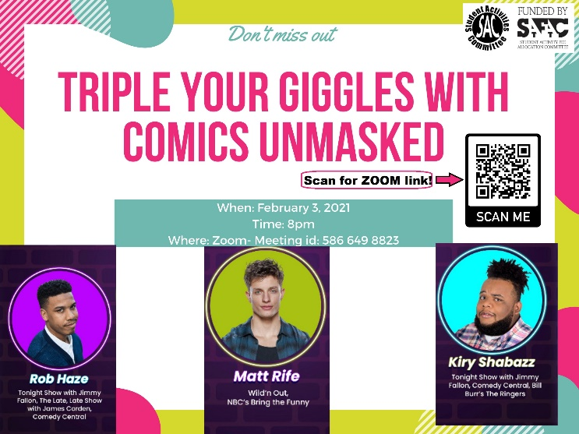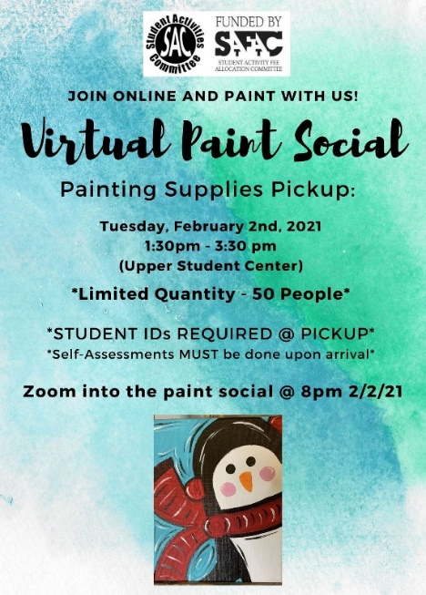

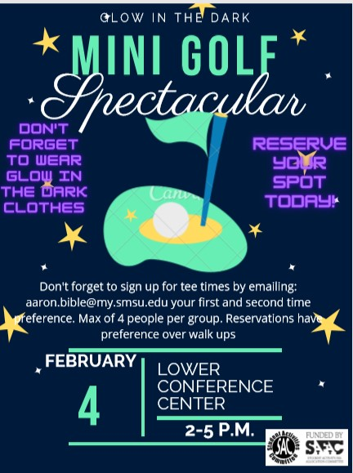

cid:image004.png@01D67FC4.6416C620

**Next issue:** Volume 2 Issue 11 will arrive February 16.

Image

A publication of the SMSU [Center for International Education](https://nam02.safelinks.protection.outlook.com/?url=https%3A%2F%2Fwww.smsu.edu%2Fadmission%2Finternational%2Findex.html&data=02%7C01%7Cmaylee.moua-vue%40smsu.edu%7C1ae8d17f27bb41c4d0e608d84e0571c9%7C5011c7c60ab446ab9ef4fae74a921a7f%7C0%7C0%7C637345132620472879&sdata=RsjiEO9uGrxKmxNMSyXgpDj9netDuA0OJ%2Fdh7KJJ%2Bbo%3D&reserved=0)

Student Center, Room 237  
[1501 State Street, Marshall, MN 56258](webextlink://1501%20State%20Street,%20Marshall,%20MN%2056258/)

**CENTER FOR INTERNATIONAL EDUCATION**

**OFFICE HOURS**

Mondays - Fridays, 8:30am - 4:30pm

Walk-In Advising available Mondays - Thursdays, 12:00pm-4:00pm.

Visit, Call, or Email us during our Office Hours.

Phone:  (507) 537-6018

Email:  [CIE@smsu.edu](mailto:CIE@smsu.edu)

