SMSU Center for International Education (CIE)   
***Global Express***Vol 02 Issue 12 | ***March 2, 2021***

cid:image004.png@01D67FC4.6416C620

* **It’s Tax Season!**
* **Yes, You Can Study Abroad!**
* **International Coffee Hours**
* **Students United Scholarship**

**It’s Tax Season!**

International students must file U.S. taxes every year ***even if you did not work***.

* If you did not work last year, you simply need to fill out the Form-8843 available in the CIE office or get it online [HERE](https://www.irs.gov/pub/irs-pdf/f8843.pdf).
* If you worked some or all of last year, you will need to collect your W-2 tax forms to file

taxes with the U.S. IRS (Internal Revenue Service). If you worked on-campus, access and print out your W-2 form by logging onto E-Services. Under My Dashboard you will see a link to your W-2.

The CIE staff are not licensed to assist with tax filing. There are several online tax services available to choose from. **Sprintax**, is a tax service that specializes in U.S. Tax Preparations for Nonresidents. You may file your taxes online through Sprintax <https://www.sprintax.com/> .

**Yes, You Can Study Abroad!**

Learn how you can study abroad while you are at SMSU.

Stop by the CIE to learn more and to schedule your appointment for study abroad advising today.

**International Coffee Hours - This Friday!**

Come to the CIE for International Coffee Hours these following **Fridays at 3:00PM-4:30PM**. Enjoy coffee, drinks, and some fun. Come early while supplies last!



* **March 5:** Celebrate International Women’s Day & Make a Goody Bag for a Woman in Your Life
* **March 19:** Origami Fun
* **April 2:**  Decorate an Easter Egg & Enjoy Some Easter Candies
* **April 16:**  Try Your Hand at Arts & Poetry
* **April 30:**  Celebrate Our Graduates!

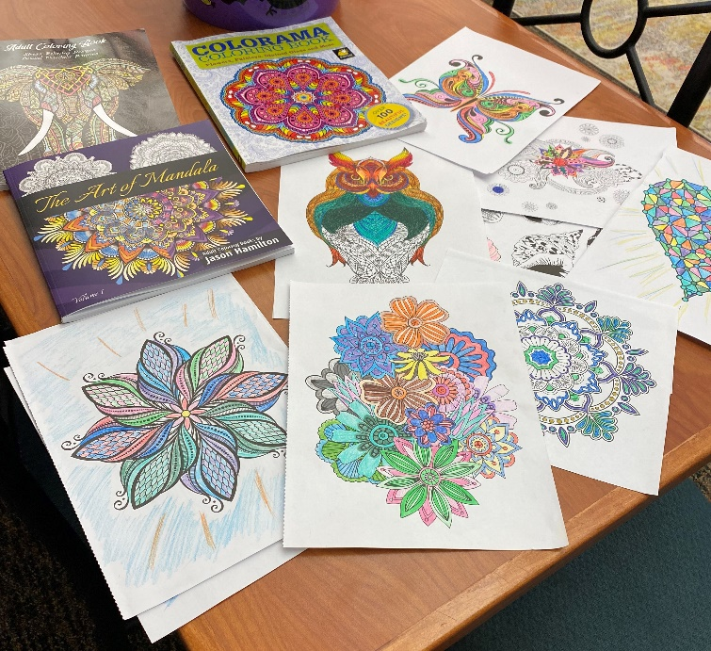Take a peek at last week’s International Coffee Hours - fun with coloring books!

**Students United Scholarship**

We have seven scholarship that are available for next year. Scholarship awards range from $500-$5,000 and are open to international and undocumented students as well.  Applications are now open and are due on April 1st. Please check out full details here: [https://www.studentsunited.org/scholarships](https://nam02.safelinks.protection.outlook.com/?url=https%3A%2F%2Fwww.studentsunited.org%2Fscholarships&data=04%7C01%7Cmaylee.moua-vue%40smsu.edu%7Cc9f2d21c8fa9468db0a508d8c94ed7de%7C5011c7c60ab446ab9ef4fae74a921a7f%7C0%7C0%7C637480687759459731%7CUnknown%7CTWFpbGZsb3d8eyJWIjoiMC4wLjAwMDAiLCJQIjoiV2luMzIiLCJBTiI6Ik1haWwiLCJXVCI6Mn0%3D%7C3000&sdata=OHvQhM7ZH%2BGCyh5vRqzm4ICCwL%2FKpj11ee8qONyYqk0%3D&reserved=0)

If you have specific questions, please reach out to our Development Intern, Mio Yoshizaki, at [development@studentsunited.org](mailto:development@studentsunited.org) or Director of Development, Christina DeVries, at [cdevries@studentsunited.org](mailto:cdevries@studentsunited.org)

cid:image004.png@01D67FC4.6416C620

**Next issue:** Volume 2 Issue 13 will arrive March 16.

Image

A publication of the SMSU [Center for International Education](https://nam02.safelinks.protection.outlook.com/?url=https%3A%2F%2Fwww.smsu.edu%2Fadmission%2Finternational%2Findex.html&data=02%7C01%7Cmaylee.moua-vue%40smsu.edu%7C1ae8d17f27bb41c4d0e608d84e0571c9%7C5011c7c60ab446ab9ef4fae74a921a7f%7C0%7C0%7C637345132620472879&sdata=RsjiEO9uGrxKmxNMSyXgpDj9netDuA0OJ%2Fdh7KJJ%2Bbo%3D&reserved=0)

Student Center, Room 237  
[1501 State Street, Marshall, MN 56258](webextlink://1501%20State%20Street,%20Marshall,%20MN%2056258/)

**CENTER FOR INTERNATIONAL EDUCATION**

**OFFICE HOURS**

Mondays - Fridays, 8:30am - 4:30pm

Walk-In Advising available Mondays - Thursdays, 12:00pm-4:00pm.

Visit, Call, or Email us during our Office Hours.

Phone:  (507) 537-6018

Email:  [CIE@smsu.edu](mailto:CIE@smsu.edu)

