SMSU Center for International Education (CIE)   
***Global Express***Vol 02 Issue 14 | ***March 30, 2021***

cid:image004.png@01D67FC4.6416C620

* **International Coffee Hours - This Friday**
* **LAST CALL - Become a Global Ambassador Next Year**
* **Etiquette Dinner**
* **Graduation Sashes - Orders Due by April 9th!**
* **Photo Contest**

**International Coffee Hours - This Friday**

Come to the CIE for International Coffee Hours these following **Fridays at 3:00PM-4:30PM**. Enjoy coffee, drinks, and some fun. Come early while supplies last!



* **April 2:**  ***Decorate an Easter Egg & Enjoy Some Easter Candies***
* **April 16:**  Try Your Hand at Arts & Poetry
* **April 30:**  If you are graduating this year, please join us - pick up your country sash and Mustang pin! If you are not graduating, come celebrate our International Graduates - complete with cake and a fun photo booth!

**LAST CALL - Become a Global Ambassador Next Year**

Work closely with the Center for International Education (CIE) throughout next year to serve as a volunteer, mentor, cultural navigator, and a global leader to assist fellow SMSU students. In addition, help coordinate the following:

• CIE cultural programs throughout the year

• Study Abroad outreach

• International Education Week (IEW)

• MISO (Mandatory International Student Orientations)

Click [HERE](https://forms.office.com/Pages/ResponsePage.aspx?id=xscRULQKq0ae9PrnSpIafy6JYX58-m1CjB8OyNCbJd9UOTBGVkZJTkZLMDBYRFJVTjFRTVFCSkxSUC4u) to submit an application **Due Friday, April 2nd!**

**Etiquette Dinner**

Learn appropriate dinner etiquette for interviewing. Register for this Zoom seminar on Wed. April 7th, 2021 at 6:00PM via smsu.joinhandshake.com.

**Graduation Sashes - Order by April 9th**

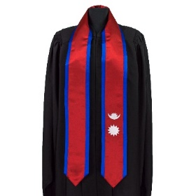SMSU will hold a Commencement ceremony on Saturday, May 8th at 10am. More information about Commencement will be coming out soon. If you are graduating and want to order your country flag sash to wear at Commencement, please stop by the CIE. ***Please bring exact cash only.*** **$30** for one country flag or **$40** for two country flags. All payments and orders are **Due NEXT WEEK FRIDAY, April 9th.**

**Photo Contest**

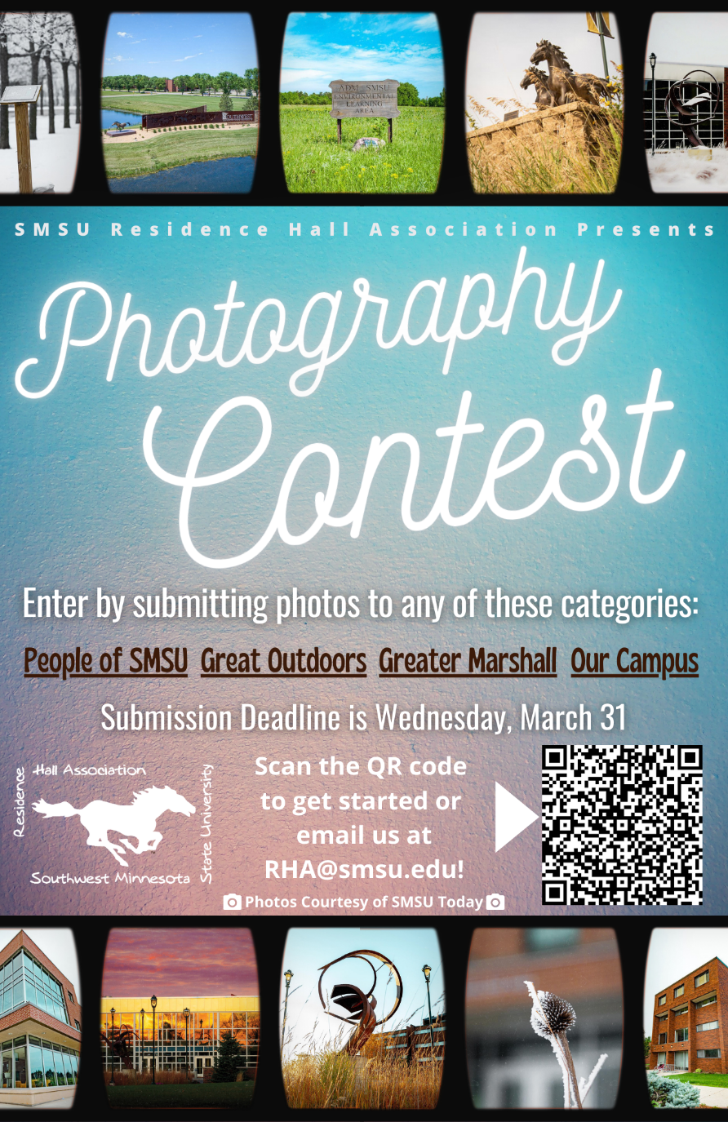

cid:image004.png@01D67FC4.6416C620

**Next issue:** Volume 2 Issue 15 will arrive April 13th

Image

A publication of the SMSU [Center for International Education](https://nam02.safelinks.protection.outlook.com/?url=https%3A%2F%2Fwww.smsu.edu%2Fadmission%2Finternational%2Findex.html&data=02%7C01%7Cmaylee.moua-vue%40smsu.edu%7C1ae8d17f27bb41c4d0e608d84e0571c9%7C5011c7c60ab446ab9ef4fae74a921a7f%7C0%7C0%7C637345132620472879&sdata=RsjiEO9uGrxKmxNMSyXgpDj9netDuA0OJ%2Fdh7KJJ%2Bbo%3D&reserved=0)

Student Center, Room 237  
[1501 State Street, Marshall, MN 56258](webextlink://1501%20State%20Street,%20Marshall,%20MN%2056258/)

**CENTER FOR INTERNATIONAL EDUCATION**

**OFFICE HOURS**

Mondays - Fridays, 8:30am - 4:30pm

Walk-In Advising available Mondays - Thursdays, 12:00pm-4:00pm.

Visit, Call, or Email us during our Office Hours.

Phone:  (507) 537-6018

Email:  [CIE@smsu.edu](mailto:CIE@smsu.edu)

