SMSU Center for International Education (CIE)   
***Global Express***Vol 02 Issue 02 | ***Sept 17, 2020***

cid:image004.png@01D67FC4.6416C620

**Address Updates Required**

International students must always have a valid international home address located in the Permanent and International address fields in your student e-Services account. You must also list a valid local address where you are residing while studying at SMSU. The US federal regulations require that you update your addresses each time you move within 10 days. Please check and make sure your addresses are accurate in e-Services.

**International Celebrations**

Please fill out this survey and share your favorite cultural holidays and celebrations from your country with other Mustangs at SMSU. We can help you share your holidays/celebrations through the CIE office and at ISO club activities. Please click on this link [International Celebrations](https://forms.office.com/Pages/ResponsePage.aspx?id=xscRULQKq0ae9PrnSpIaf5OeT_hkzPNBkIg2F0M920VURVhRNTVGUDEwSTlTNDJaODZSN1ZHSzRLWS4u)  to include your favorites.

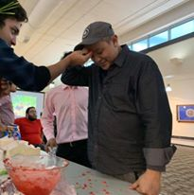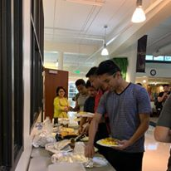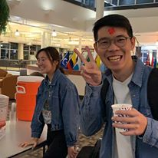

Dashain Nepali Celebration

**Join ISO**

**International Student Organization (ISO) is looking for new board members!** Develop your leadership skills and join ISO as a new board member today.ISO is always looking for new ideas and opportunities for club activities especially in this time of COVID. Don’t hesitate to send us your thoughts and ideas. [Join ISO Club](https://nam02.safelinks.protection.outlook.com/?url=https%3A%2F%2Fsouthwestmsu.campuslabs.com%2Fengage%2Forganization%2Finternationalstudentorganization&data=02%7C01%7Cmaylee.moua-vue%40smsu.edu%7C1ae8d17f27bb41c4d0e608d84e0571c9%7C5011c7c60ab446ab9ef4fae74a921a7f%7C0%7C0%7C637345132620452890&sdata=niPjdiajS6lHZbsUAeSeiUG8AvVyyAE1Pg8C5H77l7Q%3D&reserved=0)

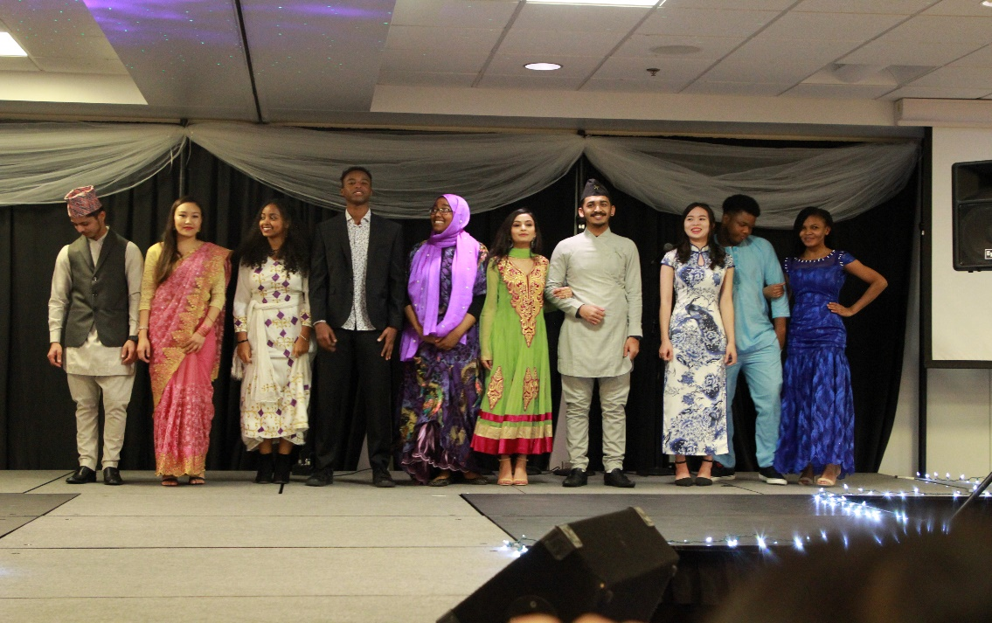

**Upcoming SMSU Events**

SMSU Career Services will host the **Agriculture Career Fair** on **Wednesday, September 23** virtually on [Handshake](https://nam02.safelinks.protection.outlook.com/?url=https%3A%2F%2Fsmsu.joinhandshake.com%2Flogin%3Frequested_authentication_method%3D674&data=02%7C01%7CKamal.West.2%40smsu.edu%7C882791746fea466e433f08d85a7df212%7C5011c7c60ab446ab9ef4fae74a921a7f%7C0%7C0%7C637358844441211492&sdata=4TsLrvAIMJ5ZrBsNjy6pF4Nlb0VtaAcpgQGTP%2BeId1Q%3D&reserved=0).  While it is named the Agriculture Career Fair, many of the employers who participate encourages all majors to apply. The attending businesses have a variety of employment needs and they welcome participation from the entire University.  Many students have already registered and plan to attend the fair, don’t miss out!

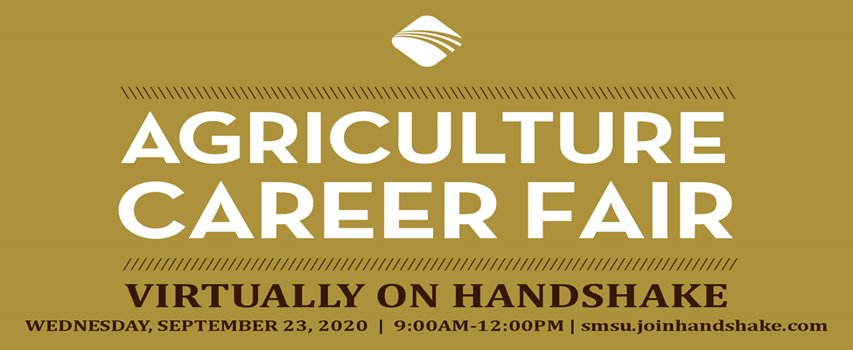

**Winter is Coming**

As we all know winter is fast approaching and the use of hats, gloves and blankets are essential. Stop by the CIE office and collect our limited supply of free hats, gloves and blankets. First come first serve. ☺

 

cid:image004.png@01D67FC4.6416C620

**Trivia of the Day! (First 6 students to come to the CIE office with the correct answers wins a goodie bag)**

1. What is the planet’s largest living structure?
   1. Solomon Island
   2. Red Sea
   3. Great Barrier Reef
2. Which flag has the same colors as the flag of Côte d’Ivoire, but reversed?
   1. India
   2. China
   3. Ireland
3. Which is one of the Official languages of Rwanda?
   1. Portuguese
   2. French
   3. Amharic
4. Which country is the largest producer and exporter of coffee in the world?
   1. Colombia b. Brazil c. Indonesia

Image

A publication of SMSU [Center for International Education](https://nam02.safelinks.protection.outlook.com/?url=https%3A%2F%2Fwww.smsu.edu%2Fadmission%2Finternational%2Findex.html&data=02%7C01%7Cmaylee.moua-vue%40smsu.edu%7C1ae8d17f27bb41c4d0e608d84e0571c9%7C5011c7c60ab446ab9ef4fae74a921a7f%7C0%7C0%7C637345132620472879&sdata=RsjiEO9uGrxKmxNMSyXgpDj9netDuA0OJ%2Fdh7KJJ%2Bbo%3D&reserved=0)

Student Center, Room 237 | [1501 State Street, Marshall, MN 56258](webextlink://1501%20State%20Street,%20Marshall,%20MN%2056258/)

**CENTER FOR INTERNATIONAL EDUCATION**

**OFFICE HOURS**

Mondays - Fridays, 8:30am - 4:30pm

Walk-In Advising available Mondays - Thursdays, 12:00pm-4:00pm.

Call, Email, or Visit during our Office Hours.

Phone:  (507) 537-6018

Email:  [CIE@smsu.edu](mailto:CIE@smsu.edu)

