SMSU Center for International Education (CIE)   
***Global Express****Vol 02 Issue 03 | October 7, 2020*

cid:image004.png@01D67FC4.6416C620

**Coffee & Tea with the CIE**

The ***Center for International Education (CIE)*** is your home away from home and we want to connect with you to see how you are doing. Our name had formally changed over the summer to the CIE (Center for International Education). Please stop by the CIE for a quick check-in and let us know how you are doing, personally and academically.  It’s really informal, we’ll buy you Starbucks Coffee or Tea and you can share with us anything from updates to any concerns you may have

Click on this [**LINK**](https://nam02.safelinks.protection.outlook.com/?url=https%3A%2F%2Fforms.office.com%2FPages%2FResponsePage.aspx%3Fid%3DxscRULQKq0ae9PrnSpIafy6JYX58-m1CjB8OyNCbJd9UOTFRRlZUQzZZQUQ2OUo5M1VRT1pLUUtHSi4u&data=02%7C01%7CKamal.West.2%40smsu.edu%7C8cece8ad7f514923e07208d86634a3f6%7C5011c7c60ab446ab9ef4fae74a921a7f%7C0%7C0%7C637371723562494349&sdata=pamOsv%2FgD1q2Ih8V2Y%2FwsBI3CbGJd3nxQ6CtqswJV1A%3D&reserved=0) to schedule your **Coffee & Tea with the CIE** session.  Virtual Zoom sessions are available as well.

***You should meet with CIE staff regularly throughout your studies, at least once or twice per semester.***  This is important if you should need help with classes, SEVIS status, and references/tips on finding future jobs amongst anything else.   We would love to be a resource for you.  We can’t wait to see you!  Please stay healthy and safe.

**Passport Renewal Required**

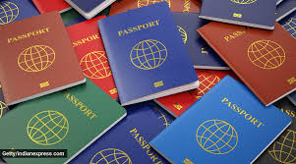International students must always have a valid international passport during your stay in the United States you. If your passport is about to expire and/or has expired please stop by Center for International Education office for the mandatory steps for passport renewal. As a rule of thumb we recommend renewing your passport at least 6 months before expiry.

**International Celebrations**

Please fill out this survey and share your favorite cultural holidays and celebrations from your country with other Mustangs at SMSU. We can help you share your holidays/celebrations through the CIE office and at ISO club activities. Please click on this link [International Celebrations](https://forms.office.com/Pages/ResponsePage.aspx?id=xscRULQKq0ae9PrnSpIaf5OeT_hkzPNBkIg2F0M920VURVhRNTVGUDEwSTlTNDJaODZSN1ZHSzRLWS4u)  to include your favorites.

**Homecoming Parade**

The annual Homecoming parade is this **Saturday, October 10th**.

We would like all ISO members to participate with a float in the parade as we do each year. We need as many members as we can get to participate and carry the flags representing all the countries from which we have students and faculty at SMSU. We will also be passing out candy to kids on the parade route. Email Kamal West at [Kamal.West.2@smsu.edu](mailto:Kamal.West.2@smsu.edu) to sign up and participate in the parade.

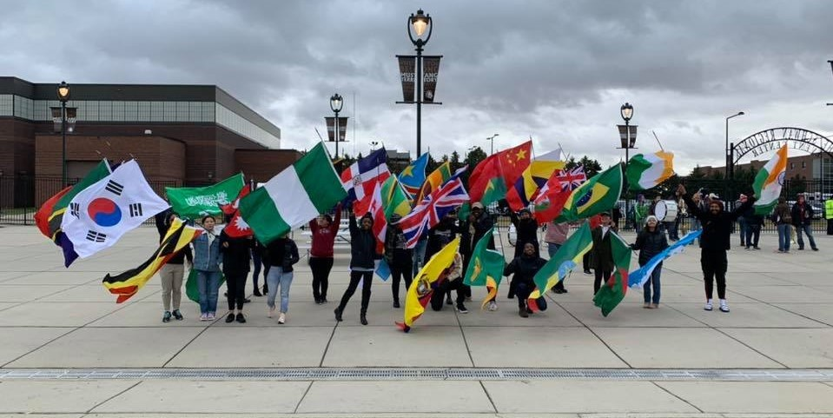

**Join ISO**

International Student Organization (ISO) is looking for new board members! Develop your leadership skills and join ISO as a new board member today.[Join ISO Club](https://nam02.safelinks.protection.outlook.com/?url=https%3A%2F%2Fsouthwestmsu.campuslabs.com%2Fengage%2Forganization%2Finternationalstudentorganization&data=02%7C01%7Cmaylee.moua-vue%40smsu.edu%7C1ae8d17f27bb41c4d0e608d84e0571c9%7C5011c7c60ab446ab9ef4fae74a921a7f%7C0%7C0%7C637345132620452890&sdata=niPjdiajS6lHZbsUAeSeiUG8AvVyyAE1Pg8C5H77l7Q%3D&reserved=0) 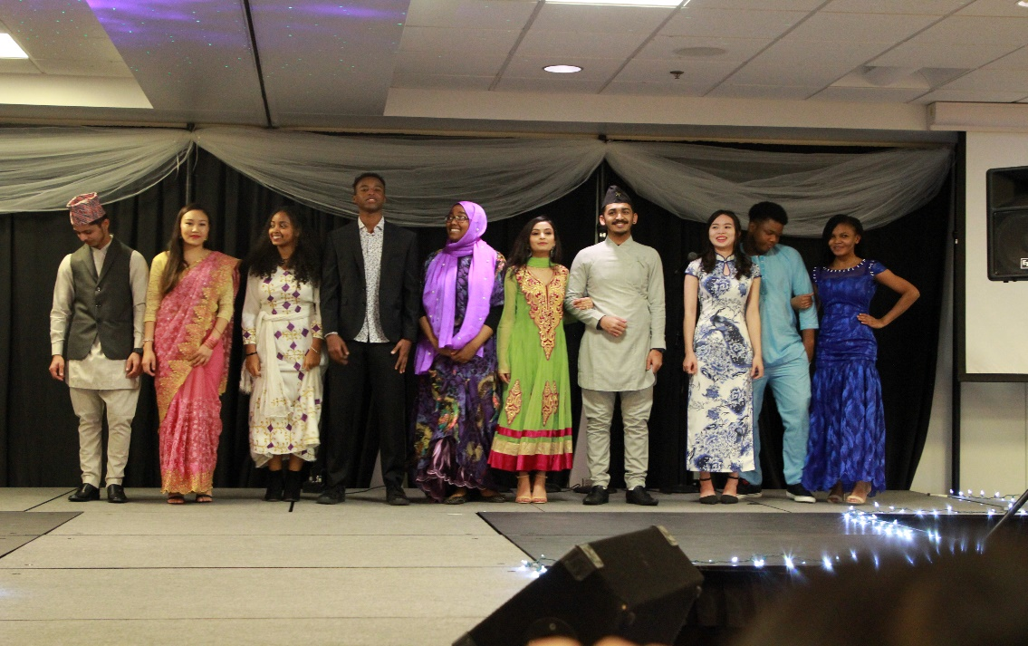

**Global Ambassadors**

Work closely with the Center for International Education (CIE) staff throughout the year to serve as a volunteer, mentor, cultural navigator, a resource person, and a global leader to assist fellow international students and co-facilitate the following:

• CIE intercultural programs throughout the year

• Study Abroad outreach

• International Education Week (IEW) events

• MISO (Mandatory International Student Orientations)

Apply today to be a ***Global Ambassador***!  Click [HERE](https://nam02.safelinks.protection.outlook.com/?url=https%3A%2F%2Fforms.office.com%2FPages%2FResponsePage.aspx%3Fid%3DxscRULQKq0ae9PrnSpIafy6JYX58-m1CjB8OyNCbJd9UODIxNlQ1WTROUkpONVkwUlAxWkRPMTNONi4u&data=02%7C01%7CKamal.West.2%40smsu.edu%7C02a129f7bc734eb1f68d08d86b0e8a78%7C5011c7c60ab446ab9ef4fae74a921a7f%7C0%7C0%7C637377057475596523&sdata=g2tb6%2B%2FWq04mWvRBsUoFW5sTcTVQEGYtkqqV0B7nxE4%3D&reserved=0) to Submit an Application, **Due Oct 23rd**!

**Winter is Coming**

As we all know winter is fast approaching and the use of hats, gloves and blankets are essential. Stop by the CIE office and select from our limited supply of free hats, gloves and blankets. First come first serve. ☺

 

**Upcoming Events**

SMSU’s **International Education Week** takes places each year as institutions around the world celebrate international education. This year it will be held on **November 16th- 20th**. International Education Week is a great opportunity to celebrate your culture at SMSU. It’s a time to promote study abroad programs and international themed events. We are looking for students willing to share information about their home countries – as individuals or in groups. Email CIE at [cie@smsu.edu](mailto:cie@smsu.edu) if you are interested.

cid:image004.png@01D67FC4.6416C620

**Trivia of the Day! Come to the CIE office with the correct answers and win a goodie bag.**

1. What is the planet’s largest living structure?
   1. Solomon Island
   2. Red Sea
   3. Great Barrier Reef
2. Which flag has the same colors as the flag of Côte d’Ivoire, but reversed?
   1. India
   2. China
   3. Ireland
3. Which is one of the Official languages of Rwanda?
   1. Portuguese
   2. French
   3. Amharic
4. Which country is the largest producer and exporter of coffee in the world?
   1. Colombia b. Brazil c. Indonesia

Image

A publication of SMSU [Center for International Education](https://nam02.safelinks.protection.outlook.com/?url=https%3A%2F%2Fwww.smsu.edu%2Fadmission%2Finternational%2Findex.html&data=02%7C01%7Cmaylee.moua-vue%40smsu.edu%7C1ae8d17f27bb41c4d0e608d84e0571c9%7C5011c7c60ab446ab9ef4fae74a921a7f%7C0%7C0%7C637345132620472879&sdata=RsjiEO9uGrxKmxNMSyXgpDj9netDuA0OJ%2Fdh7KJJ%2Bbo%3D&reserved=0)

Student Center, Room 237 | [1501 State Street, Marshall, MN 56258](webextlink://1501%20State%20Street,%20Marshall,%20MN%2056258/)

**CENTER FOR INTERNATIONAL EDUCATION**

**OFFICE HOURS**

Mondays - Fridays, 8:30am - 4:30pm

Walk-In Advising available Mondays - Thursdays, 12:00pm-4:00pm.

Call, Email, or Visit during our Office Hours.

Phone:  (507) 537-6018

Email:  [CIE@smsu.edu](mailto:CIE@smsu.edu)

