SMSU Center for International Education (CIE)   
***Global Express****Vol 02 Issue 04 | October 21, 2020*

cid:image004.png@01D67FC4.6416C620

C I E / I S O E V E N T R E P O R T

* Homecoming Parade Fun

W H A T ‘ S N E W ?

* Vote in the Mock US Presidential Elections

C I E O P P O R T U N I T I E S

* Global Ambassadors Assemble!
* $1,000 Student Recruitment Incentive

U P C O M I N G E V E N T S

* Farmers to Families Food Box
* Res-Hall-oween Door Decor Contest
* Diversity & Inclusion Virtual Career Fair
* Halloween Haunted Tower
* The US Presidential Mock Election
* International Education Week

C I E / I S O E V E N T R E P O R T

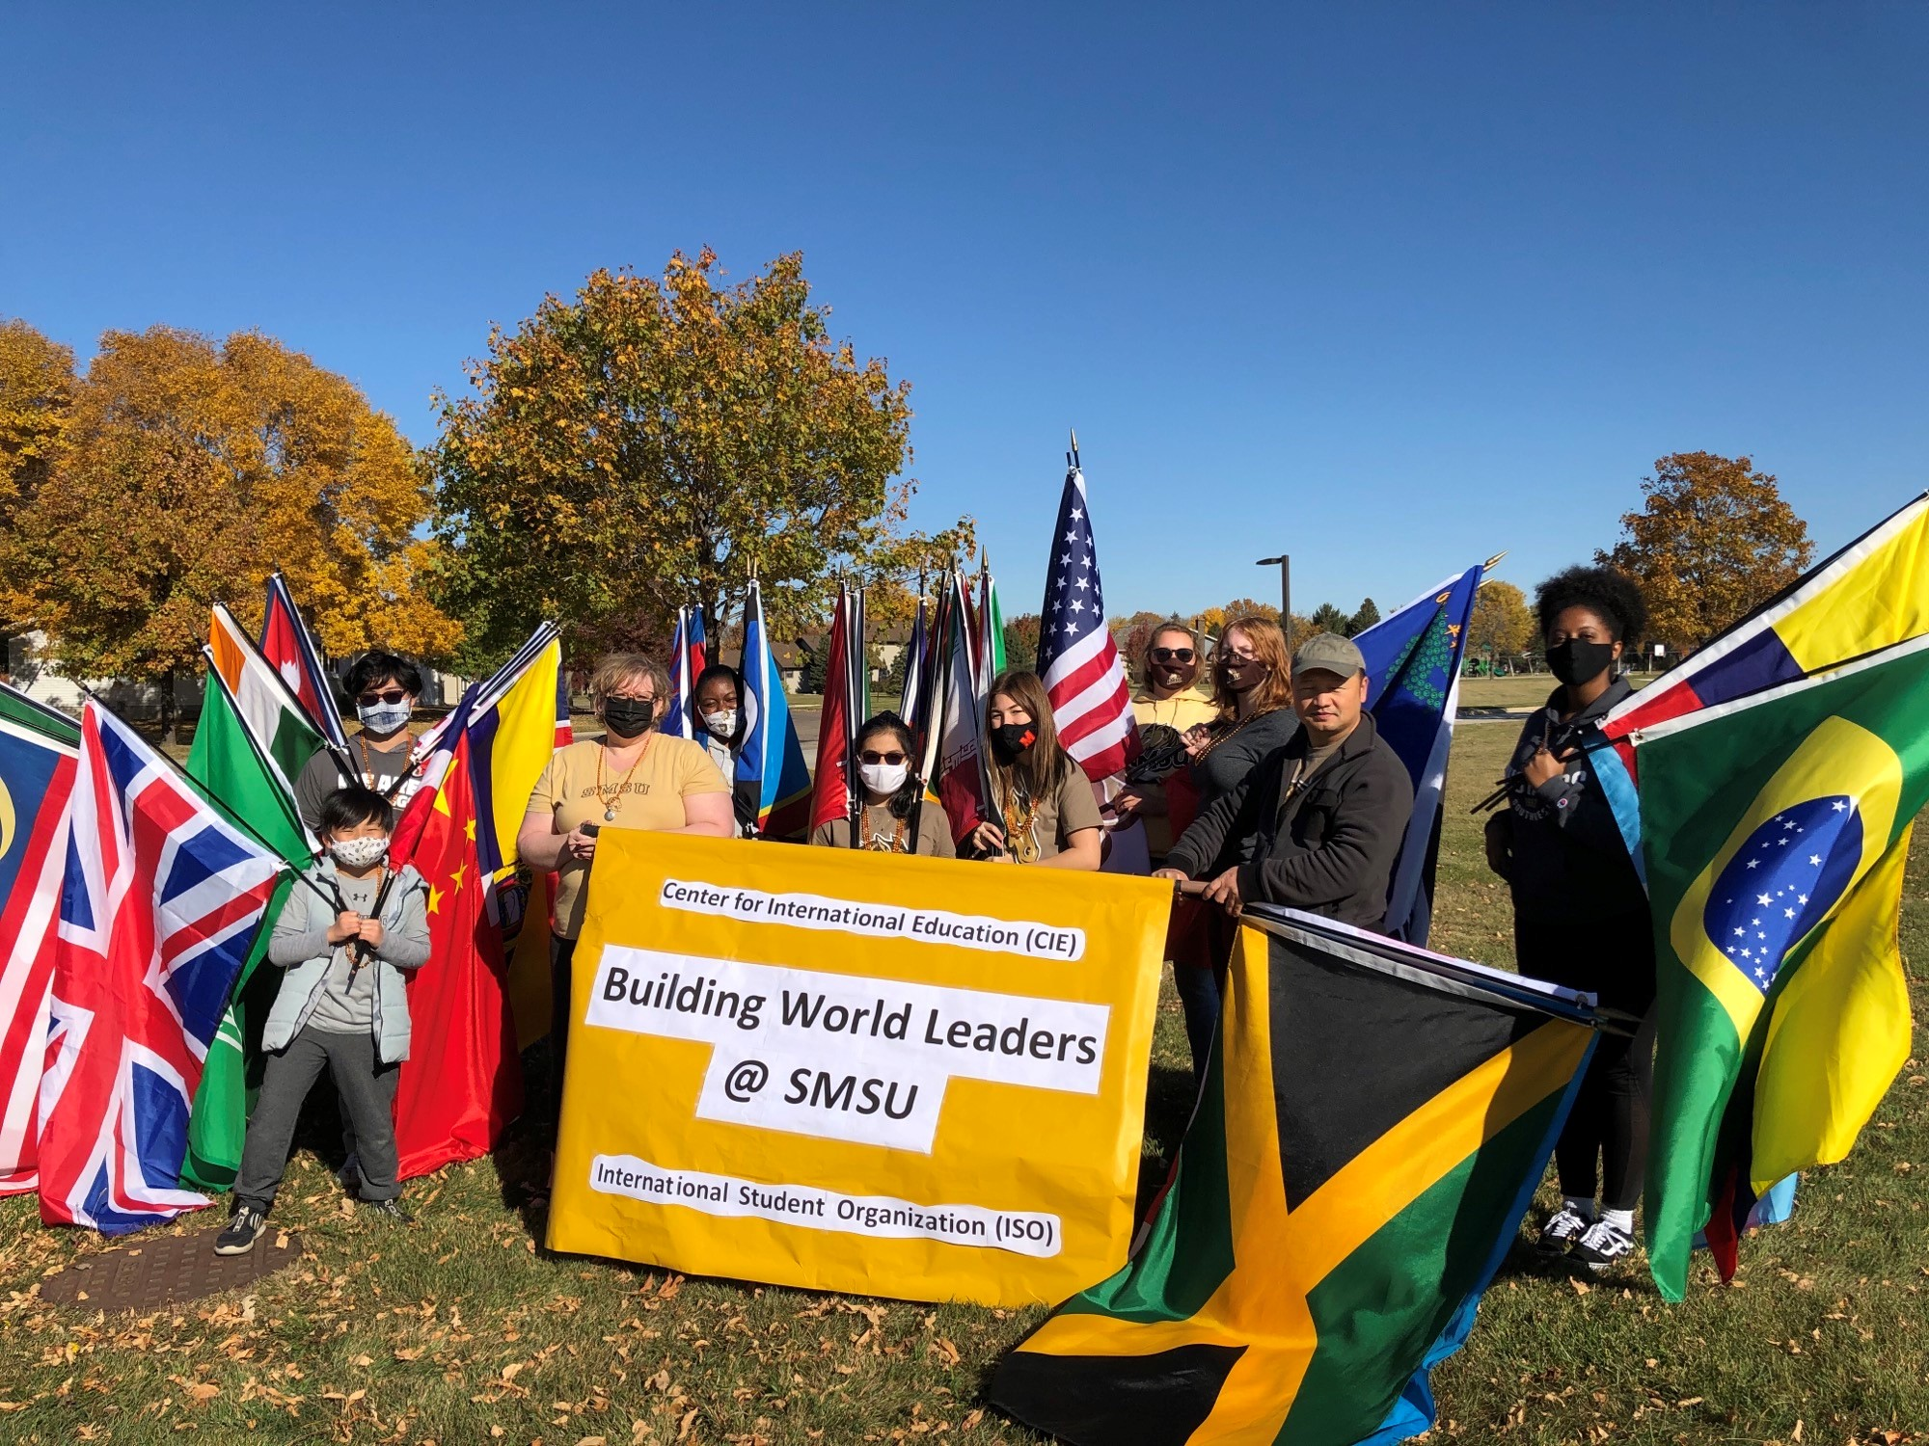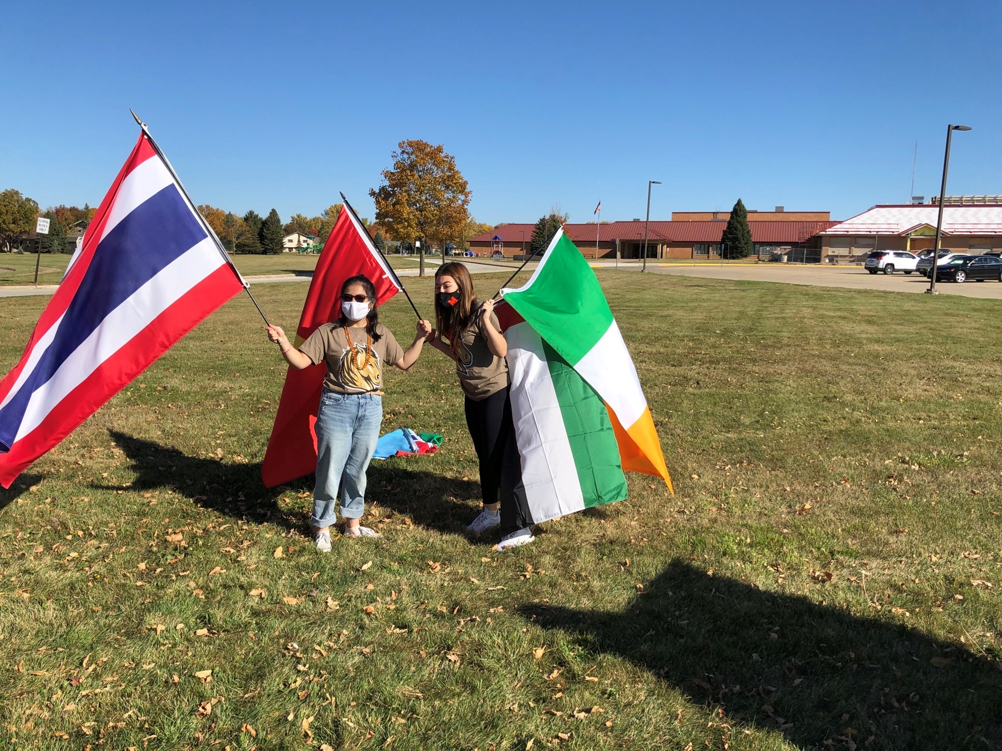

**Homecoming Parade Fun**

We kicked off SMSU’s great tradition - the 2020 Annual Homecoming Parade.

15 students and other friends of CIE/ISO from Ethiopia, France, Ireland, Bermuda, Nigeria and USA had fun as they marched through downtown Marshall waving international flags from 30 countries; through Lyon Street to Main Street, concluding at the 5th Street intersection. A big thank you to all those who participated in the homecoming parade, your efforts are very much appreciated!

W H A T ‘ S N E W ?

**Vote in the *Mock* US Presidential Elections**10:00 – 5:00pm @ SC 241 Gallery (next to CIE office)

Nov 3rd is Election Day all across the U.S. Come vote in the ***Mock*** U.S. Presidential Election to voice who you think should be the next U.S. President.

Don’t miss out on this historic day. Learn about the election process for the 2020 U.S. Presidential Elections from past US Congress candidate (2004) SMSU Prof. Sturrock in a special presentation. Snacks, drinks & socially distanced fun. Drop by to follow elections results Live on large screen TV.

O P P O R T U N I T I E S

**Global Ambassadors *Assemble!***Grab this chance to work closely with the Center for International Education (CIE) staff throughout the year to serve as a volunteer, mentor, cultural navigator, a resource person, and a global leader. Assist fellow international students and co-facilitate:

* CIE inter-cultural programs
* Study Abroad outreach
* International Education Week (IEW) events
* MISO (Mandatory International Student Orientations)

>> Apply today to be a [***Global Ambassador***](https://nam02.safelinks.protection.outlook.com/?url=https%3A%2F%2Fforms.office.com%2FPages%2FResponsePage.aspx%3Fid%3DxscRULQKq0ae9PrnSpIafy6JYX58-m1CjB8OyNCbJd9UODIxNlQ1WTROUkpONVkwUlAxWkRPMTNONi4u&data=02%7C01%7CKamal.West.2%40smsu.edu%7C02a129f7bc734eb1f68d08d86b0e8a78%7C5011c7c60ab446ab9ef4fae74a921a7f%7C0%7C0%7C637377057475596523&sdata=g2tb6%2B%2FWq04mWvRBsUoFW5sTcTVQEGYtkqqV0B7nxE4%3D&reserved=0) by this **Friday, Oct 23**.

**SMSU Offers $1,000 Student Recruitment Incentive**

Have a friend or family member thinking of coming to study at SMSU? SMSU will award any currently enrolled international student with $1,000 in tuition credit for each new international student they recruit who enrolls and attends SMSU (terms & conditions apply). The tuition credit is awarded at the start of the second semester. You may receive credit for up to 5 students per semester. For more details about this opportunity ask any staff member at the CIE office.

U P C O M I N G    E V E N T S

**Oct 22, THURSDAY  
Farmers to Families Food Box**  
*4:00pm* @ Grace Life Church601 E College Dr. All are welcome!   
>> Just drive up and have a Food Box loaded into your vehicle.

**Now - Oct 26, MONDAY  
Res-Hall-oween Door Decor Contest***12:00 noon* deadline!Gift baskets to the 3 best doors on campus via Facebook likes.   
>> [Submit](mailto:RHA@smsu.edu) your entry (door photo) today.

**Oct 29, THURSDAY  
Diversity & Inclusion Virtual Career Fair***11:00 – 4:00pm*Looking for a job/internship for CPT or OPT? Open to Diverse Students & Alumni from Colleges and Universities throughout the U.S.   
>> [More](https://careereco.com/Fair/EventDetails?fairId=8fcbd5f0-99b7-42f4-a08f-ac370124ac8b) info. [Register](https://careereco.com/User/LogIn?ReturnUrl=%2fUser%2fFairRegistration%3ffairId%3d8fcbd5f0-99b7-42f4-a08f-ac370124ac8b&fairId=8fcbd5f0-99b7-42f4-a08f-ac370124ac8b) here.

**Oct 30-31, FRIDAY - SATURDAY  
Halloween Haunted Tower***7:00 – 11:00pm* @ Erie RoadThe Fire Tower at the MERIT Center in Marshall is haunted... during Halloween weekend only. Prepare yourself for a night of thrills and chills all the way up the 5-floor tower: The Mysterious Maze, Hotel of Horrors, The Butcher Shop, Insane Asylum, etc. By reservation only. Groups of 6 (if same household) or 4 (if not same household).  
>> [More](https://www.visitmarshallmn.com/index.php/plan/events-calendar/event/1825-haunted-tower-on-erie-road) info. Select your [time-slot](https://www.signupgenius.com/go/10C0D4CAFA728A3F8C52-haunted) today.

**Help out at this event, acting volunteers are needed…**No prior acting experience needed. >> More info, contact: [Allie Lamote](mailto:allie.lamote@my.smsu.edu).  
Signup sheet on the SMSU Drama Club noticeboard @ outside FA112

**Nov 03, TUESDAY  
The US Presidential Mock Election***10:00 – 5:00pm* @SC 243 Gallery (next to CIE office)Special historic event (actual Election Day!) to familiarize international students with the 2020 U.S. Presidential Elections how’s & why’s. Snacks & drinks. Cast a *mock vote* & follow elections results Live on TV all day.

**Nov 16-20, MONDAY - FRIDAY  
International Education Week**SMSU and other institutions around the world celebrate international education during this week. It’s a time to promote study abroad programs and international themed events. We are looking for students willing to share information about their home countries as individuals or groups. Presentations/ talks/ games/ food/ drinks/ performance/ art /etc… all week long.    
>> [Email](mailto:cie@smsu.edu) us if you are interested.

H U M O R

***The Coronavirus Chronicles #84***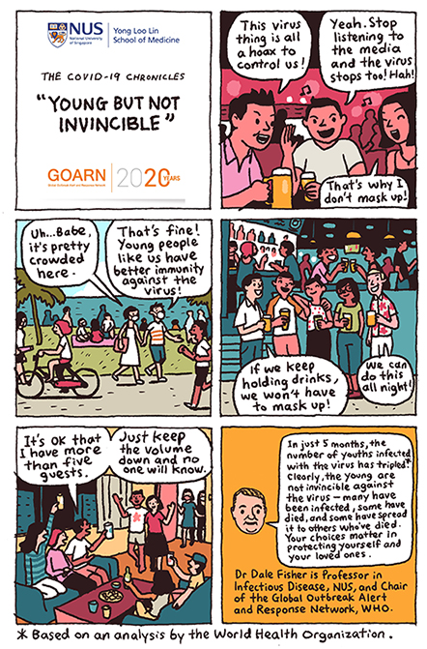     
“The COVID-19 Chronicles” is a series of educational illustrations (comics!) about the ongoing COVID-19 outbreak published by the National University of Singapore (NUS) Yong Loo Lin School of Medicine. >> [Get more](mailto:https://nam02.safelinks.protection.outlook.com/?url=https%3A%2F%2Fnusmedicine.nus.edu.sg%2Fmedias%2Fnews-info%2F2233-the-covid-19-chronicles&data=02%7C01%7Ckenneth.lam%40my.smsu.edu%7Cfaed728f7a1943dc844008d7d4f1f706%7C5011c7c60ab446ab9ef4fae74a921a7f%7C0%7C0%7C637212008216686502&sdata=xuFo9%2BM7TFSjIFQQHisS7f3c3G75WKKeNWT%2FrfEz240%3D&reserved=0).

**////////////////////////////////////////////////////////////////////////////**

Stay vigilant and enjoy Halloween next week!cid:image004.png@01D67FC4.6416C620

**Next issue #05:** Nov 03, 2020

Image

A publication of SMSU [Center for International Education](https://nam02.safelinks.protection.outlook.com/?url=https%3A%2F%2Fwww.smsu.edu%2Fadmission%2Finternational%2Findex.html&data=02%7C01%7Cmaylee.moua-vue%40smsu.edu%7C1ae8d17f27bb41c4d0e608d84e0571c9%7C5011c7c60ab446ab9ef4fae74a921a7f%7C0%7C0%7C637345132620472879&sdata=RsjiEO9uGrxKmxNMSyXgpDj9netDuA0OJ%2Fdh7KJJ%2Bbo%3D&reserved=0)

Student Center, Room 237 | [1501 State Street, Marshall, MN 56258](webextlink://1501%20State%20Street,%20Marshall,%20MN%2056258/)

**CENTER FOR INTERNATIONAL EDUCATION**

**OFFICE HOURS**

Mondays - Fridays, 8:30am - 4:30pm

Walk-In Advising available Mondays - Thursdays, 12:00pm-4:00pm.

Call, Email, or Visit during our Office Hours.

Phone:  (507) 537-6018

Email:  [CIE@smsu.edu](mailto:CIE@smsu.edu)

