SMSU Center for International Education (CIE)   
***Global Express****Vol 02 Issue 05 | October 05, 2020*

cid:image004.png@01D67FC4.6416C620

C I E U P D A T E S

* Mock US Presidential Elections Result

C I E O P P O R T U N I T I E S

* $1,000 Student Recruitment Incentive

U P C O M I N G E V E N T S

* International Education Week (IEW)

H U M O R

C I E U P D A T E S

**HERE ARE THE RESULTS OF THE CIE MOCK ELECTIONS….**

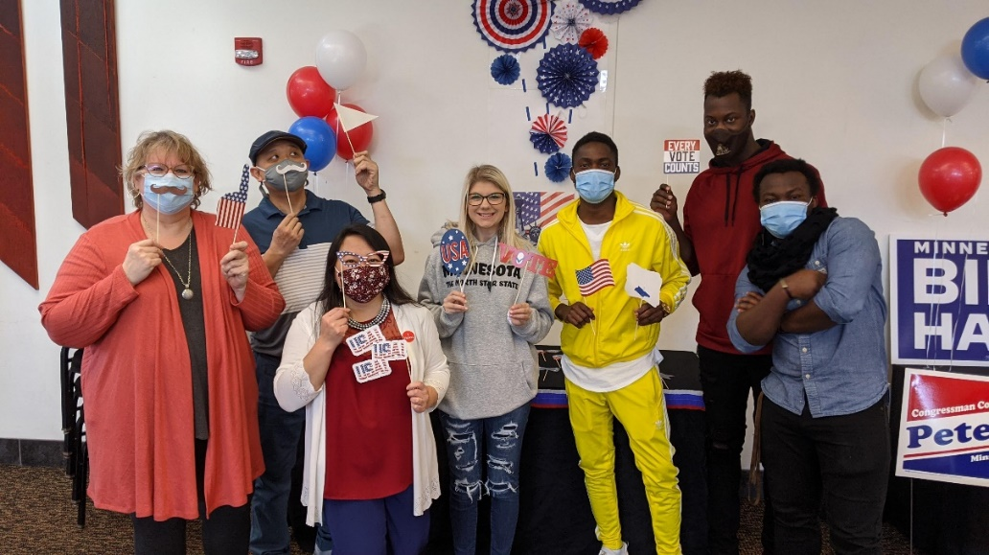

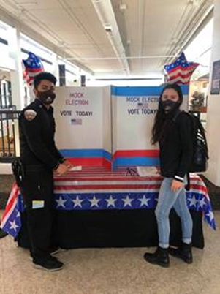 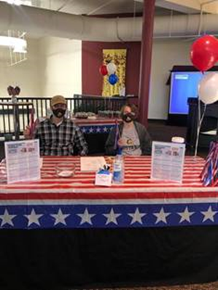

Thanks to all the faculty, staff and students who stopped by to join in on the fun and festivities. We had over 50 participants who stopped in throughout the day. Several international students were very happy to learn more about the U.S. Presidential election and to cast their ballot for the first time. We received an amazing total of 32 Non-Citizen Votes!

|  |  |
| --- | --- |
| **President/Vice President** | Biden- Kamala (we had 5 votes for Kanye West by the way!) |
| **US senator** | Tina Smith |
| **US Representative** | Collin Peterson |
| **State Senator** | Steve Preslicka |
| **State Representative** | Doria Drost |
| **Marshall City Mayor** | Noel Ayala & Bob Byrnes tied for Mayor |
| **School Board Members** | Muna Mohamed, Bill Mulso, Ben Walker (go Mustangs!) |

C I E O P P O R T U N I T I E S

**SMSU Offers $1,000 Student Recruitment Incentive**

Have a friend or family member thinking of coming to study at SMSU? SMSU will award any currently enrolled international student with $1,000 in tuition credit for each new international student they recruit who enrolls and attends SMSU (terms & conditions apply). The tuition credit is awarded at the start of the second semester. You may receive credit for up to 5 students per semester. For more details about this opportunity ask any staff member at the CIE office.

U P C O M I N G    E V E N T S

**Nov 16-20, MONDAY - FRIDAY  
International Education Week**SMSU and other institutions around the world celebrate international education during this week. It’s a time to promote study abroad programs and international themed events. Join us for these events!

* + **International Music Fest** Celebrate International Education and listen to international music all week long at the Student Center.  Featuring all kinds of music from different cultures.  Enjoy!
  + **Study Abroad** Pick-up information and goodies at Study Abroad information tables in the Student Center between 11am-1pm.  Come learn how you can Study Abroad in the future.
  + **Global Treats & Trivia:**  Stop by the CIE during our office hours all week long to answer international trivia and pick-up some international treats!  Here’s your chance to learn something new and try out international treats.
  + **Special Guest Speaker:**  GoinGlobal is an online service offered by Career Service to help SMSU students and alums find jobs, internships, and volunteer opportunities around the world.  Join Ms. Mary Anne Thompson, ***GoinGlobal*** Founder and President for a special virtual session on ***A Global Perspective on the Evolution of Employment in the World of Covid-19***.  Topics will include:  the future of work, areas of job promise, emerging job markets, virtual networking and job interviewing tips, and working from home.  **Tuesday, November 17th, at 2:00pm via virtual webinar.**

**Email** [**careers@smsu.edu**](mailto:careers@smsu.edu) **to sign up and receive the webinar link.**

* + **A Taste of Cultures:**  Learn about another country and culture from your international peers at SMSU.  A special cuisine will be featured so you can enjoy a taste of their culture.  **Limited to the first 20 people (per session) who signs up in advance by emailing** [**cie@smsu.edu**](mailto:cie@smsu.edu)**.**  **Do not wait and sign up today to reserve your spot today.**
    - **Latinx: Monday, Nov 16th @ 4pm, Conference Center**
    - **Ireland:  Wednesday, November 18th @4pm, Conference Center**
    - **Ethiopia:  Thursday, November 19th @ 4pm, Conference Center**
    - **Malaysia:  Friday, November 20th @4pm, Conference Center**

H U M O R

And as for the Real Election, Here’s What We Know So Far…

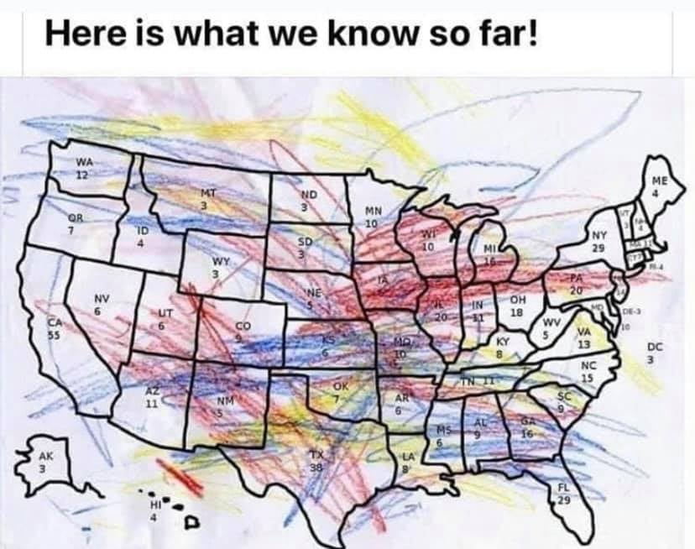

Popular FB meme, author unknown.

**Next issue #07:** Nov 18, 2020

Image

A publication of SMSU [Center for International Education](https://nam02.safelinks.protection.outlook.com/?url=https%3A%2F%2Fwww.smsu.edu%2Fadmission%2Finternational%2Findex.html&data=02%7C01%7Cmaylee.moua-vue%40smsu.edu%7C1ae8d17f27bb41c4d0e608d84e0571c9%7C5011c7c60ab446ab9ef4fae74a921a7f%7C0%7C0%7C637345132620472879&sdata=RsjiEO9uGrxKmxNMSyXgpDj9netDuA0OJ%2Fdh7KJJ%2Bbo%3D&reserved=0)

Student Center, Room 237 | [1501 State Street, Marshall, MN 56258](webextlink://1501%20State%20Street,%20Marshall,%20MN%2056258/)

**CENTER FOR INTERNATIONAL EDUCATION**

**OFFICE HOURS**

Mondays - Fridays, 8:30am - 4:30pm

Walk-In Advising available Mondays - Thursdays, 12:00pm-4:00pm.

Call, Email, or Visit during our Office Hours.

Phone:  (507) 537-6018

Email:  [CIE@smsu.edu](mailto:CIE@smsu.edu)

