SMSU Center for International Education (CIE)   
***Global Express****Vol 02 Issue 06 | November 17, 2020*

cid:image004.png@01D67FC4.6416C620

C I E U P D A T E S

* Global Ambassadors
* Address Updates Required
* Passport Renewal Reminders

C I E O P P O R T U N I T I E S

* $1,000 Student Recruitment Incentive

U P C O M I N G E V E N T S

* International Education Week (IEW)
* Thanksgiving Dinner

C I E U P D A T E S

**Introducing the Global Ambassadors**

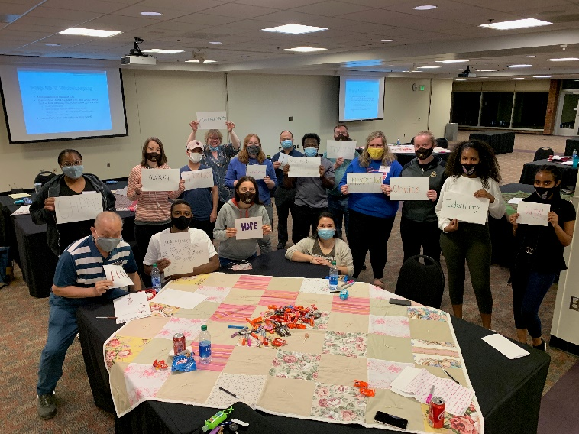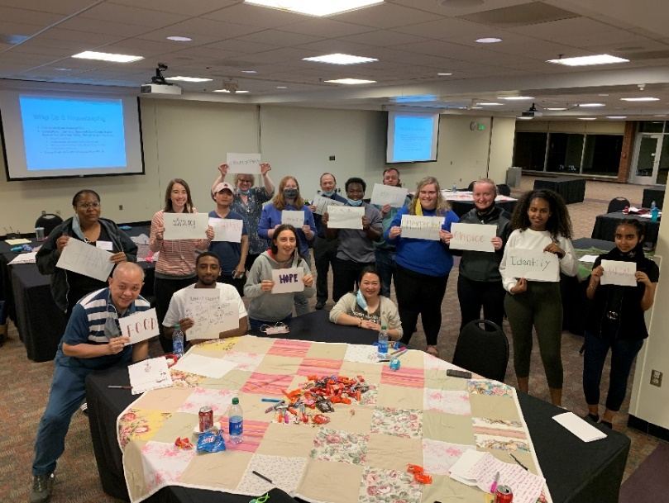

Congratulations to our Global Ambassadors: Hailey Nierling, Tesfa Desta, Jayla Burt, Savannah Stafford, Caitlyn Reagan, Eric Alves, Lee Xiong, Betselot Berhanu, Moshood Agboola, Katie Medford, and Mieraf Dagne! These student leaders will be helping CIE with programmatic events and mentoring new international students in the future.

**Address Updates Required**

International students must always have a valid international home address located in the Permanent and International address fields in your student e-Services account. You must also list a valid local address where you are residing while studying at SMSU. The US federal regulations require that you update your addresses each time you move within 10 days. Please check and make sure your addresses are accurate in e-Services.

**Passport Renewal Required**

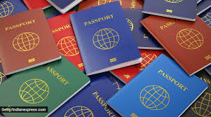International students must always have a valid international passport during your stay in the United States you. If your passport is about to expire and/or has expired please stop by Center for International Education office for the mandatory steps for passport renewal. As a rule of thumb we recommend renewing your passport at least 6 months before expiry.

C I E O P P O R T U N I T I E S

**SMSU Offers $1,000 Student Recruitment Incentive**

Have a friend or family member thinking of coming to study at SMSU? SMSU will award any currently enrolled international student with $1,000 in tuition credit for each new international student they recruit who enrolls and attends SMSU (terms & conditions apply). The tuition credit is awarded at the start of the second semester. You may receive credit for up to 5 students per semester. For more details about this opportunity ask any staff member at the CIE office.

U P C O M I N G    E V E N T S

**International Education Week**SMSU and other institutions around the world celebrate international education during this week. It’s a time to promote study abroad programs and international themed events. Join us for these events!

* + **International Music Fest** Celebrate International Education and listen to international music all week long at the Student Center.  Featuring all kinds of music from different cultures.  Enjoy!
  + **Study Abroad** Pick-up information and goodies at Study Abroad information tables in the Student Center between 11am-1pm.  Come learn how you can Study Abroad in the future.
  + **Global Treats & Trivia:**  Stop by the CIE during our office hours all week long to answer international trivia and pick-up some international treats!  Here’s your chance to learn something new and try out international treats.
  + **Special Guest Speaker:**  GoinGlobal is an online service offered by Career Service to help SMSU students and alums find jobs, internships, and volunteer opportunities around the world.  Join Ms. Mary Anne Thompson, ***GoinGlobal*** Founder and President for a special virtual session on ***A Global Perspective on the Evolution of Employment in the World of Covid-19***.  Topics will include:  the future of work, areas of job promise, emerging job markets, virtual networking and job interviewing tips, and working from home.  **Tuesday, November 17th, at 2:00pm via virtual webinar.**

**Email** [**careers@smsu.edu**](mailto:careers@smsu.edu) **to sign up and receive the webinar link.**

* + **A Taste of Cultures:**  Learn about another country and culture from your international peers at SMSU.  A special cuisine will be featured so you can enjoy a taste of their culture.  **Limited to the first 20 people (per session) who signs up in advance by emailing** [**cie@smsu.edu**](mailto:cie@smsu.edu)**.**  **Do not wait and sign up today to reserve your spot today.**
    - **Ireland:  Wednesday, November 18th @4pm, Conference Center**
    - **Ethiopia:  Thursday, November 19th @ 4pm, Conference Center**
    - **Malaysia:  Friday, November 20th @4pm, Conference Center**

**International Education Taste of Cultures** [**registration link**](https://mnscu-my.sharepoint.com/:x:/r/personal/nl4666fh_minnstate_edu/_layouts/15/Doc.aspx?sourcedoc=%7B5FE9E091-8236-48AF-B8BD-6E8855BBF19C%7D&file=IEW%20Taste%20of%20Cultures%20Registration%20List.xlsx&action=default&mobileredirect=true&cid=058f9322-1c1d-4597-b413-9079c9be6d1f)

**Free Thanksgiving Dinner**

Holy Redeemer Catholic Campus Ministry is hosting a Thanksgiving Dinner, Thursday November 26, 2020. Pickup 12:00– 12:30 pm. To register [click here](https://m.signupgenius.com/#!/showSignUp/20f0a4aa9ae28a0f49-thanksgiving).

**Next issue:** Dec 2, 2020cid:image008.png@01D67FC4.6416C620

A publication of SMSU [Center for International Education](https://nam02.safelinks.protection.outlook.com/?url=https%3A%2F%2Fwww.smsu.edu%2Fadmission%2Finternational%2Findex.html&data=02%7C01%7Cmaylee.moua-vue%40smsu.edu%7C1ae8d17f27bb41c4d0e608d84e0571c9%7C5011c7c60ab446ab9ef4fae74a921a7f%7C0%7C0%7C637345132620472879&sdata=RsjiEO9uGrxKmxNMSyXgpDj9netDuA0OJ%2Fdh7KJJ%2Bbo%3D&reserved=0)

Student Center, Room 237 | [1501 State Street, Marshall, MN 56258](webextlink://1501%20State%20Street,%20Marshall,%20MN%2056258/)

**CENTER FOR INTERNATIONAL EDUCATION**

**OFFICE HOURS**

Mondays - Fridays, 8:30am - 4:30pm

Walk-In Advising available Mondays - Thursdays, 12:00pm-4:00pm.

Call, Email, or Visit during our Office Hours.

Phone:  (507) 537-6018

Email:  [CIE@smsu.edu](mailto:CIE@smsu.edu)

