SMSU Center for International Education (CIE)   
***Global Express****Vol 02 Issue 07 | December 2, 2020*

cid:image004.png@01D67FC4.6416C620

C I E U P D A T E S

* IEW Recap
* Register for Spring Classes
* Free COVID Testing

C I E U P D A T E S

**International Education Week (IEW) Recap**

International Education Week was filled with celebratory and educational events.

* **Global Treats & Trivia** was a hit with numerous students stopping by the CIE to try out their trivia skills. Snacks from Belgium, Japan, South Korea, Poland, England, Turkey, and Nigerian (African) were available to all that stopped by.
* The **Study Abroad Information Table** welcomed inquiries from 25 current students who are interested in studying abroad in the future.
* The **Taste of Cultures** series featuring LatinX, Ireland, Ethiopia, and Malaysia were a hit. Each session was a full house (25 max), the student presenters shared information about their country, culture, and a “taste” of popular dishes from those countries.
* All week long, the Student Center played **international music** from around the world.

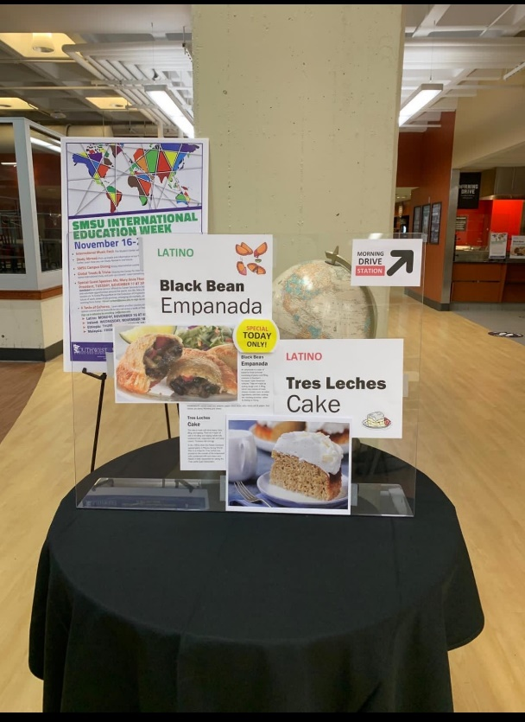 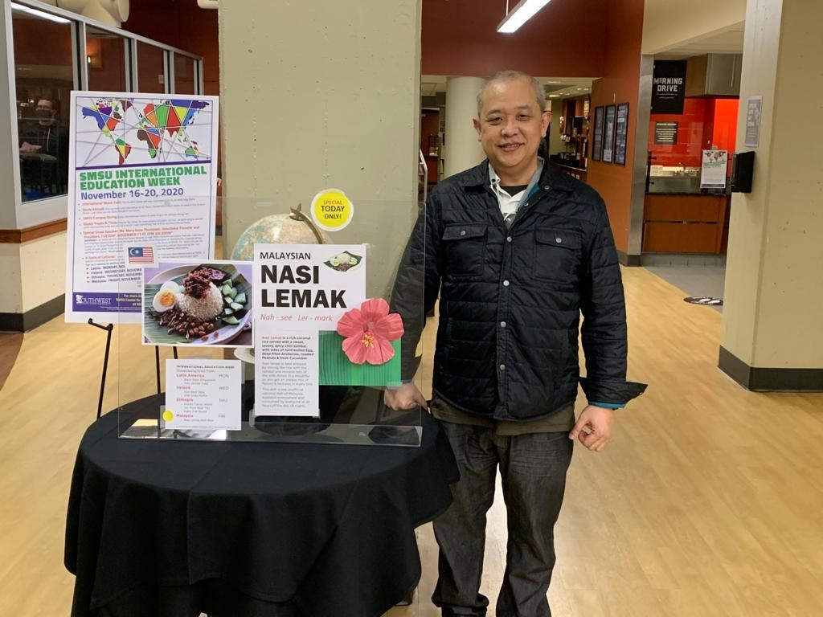

Dining Services offered international food all week.

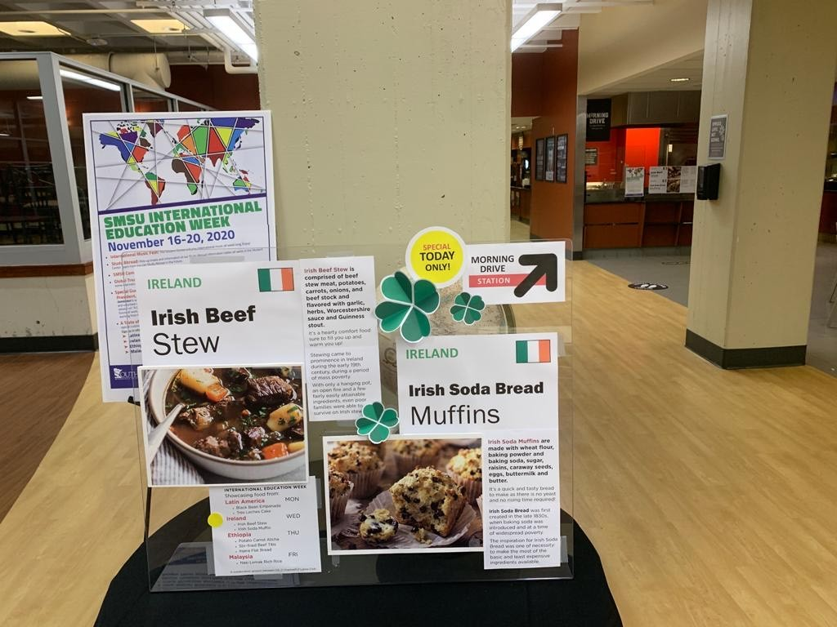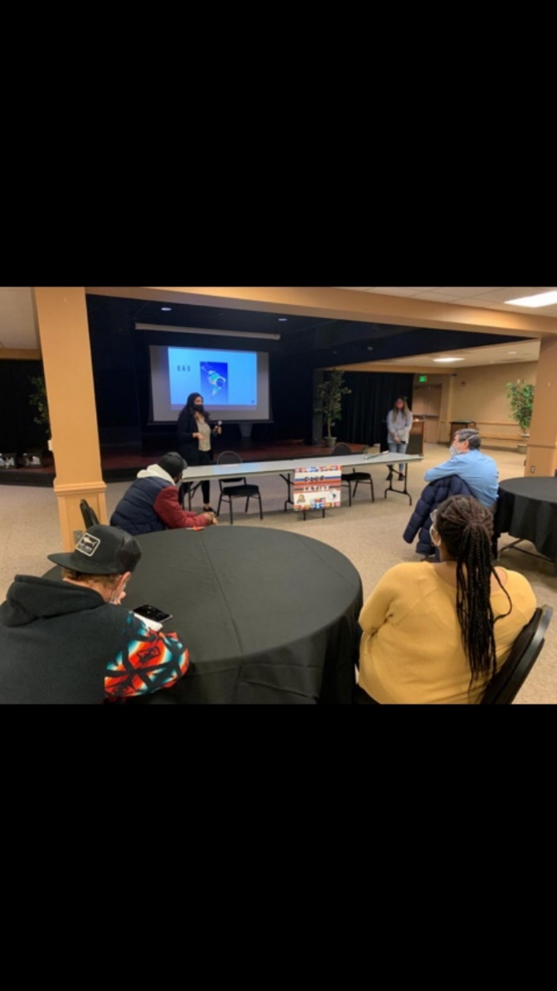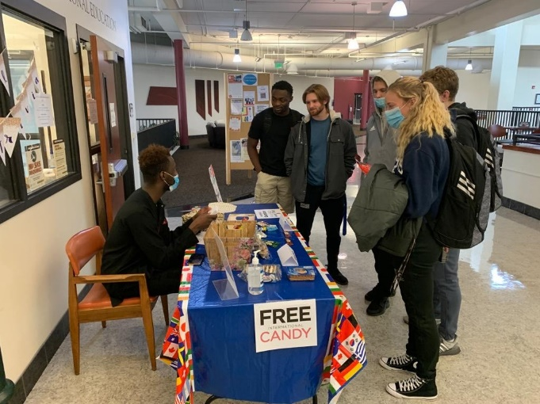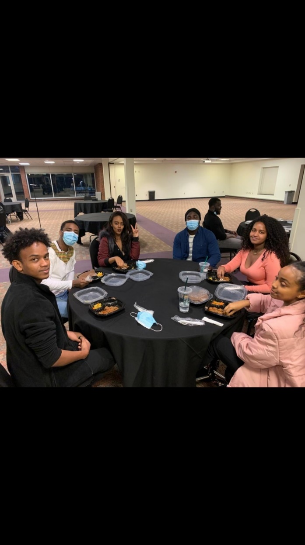Taste of Cultures (Latinx (left) & Ethiopia (right)

Global Treats & Trivia (left) & Irish Food in Dining Services (right)

**Register for Spring Classes**

Classes begin January 11th, 2021. The last day to add/ or drop a class is Jan 15th, 2021.

[Click here](https://www.smsu.edu/resources/webspaces/calendars/acadcalendar202021.pdf) for 2020-20221 Academic Calendar. **Due to COVID, international students are permitted to enroll for more than one online course. However, please remember to enroll for at least one in-person or hybrid course to maintain your legal status.**

**FREE COVID Testing**

* **Free COVID-19 saliva test kits** are available from Student Health Services in BA Rm 158, Monday-Friday 9:00AM to 4:00PM.
* **Free testing available through the Hy-Vee Pharmacy** by completing a pre-registration at doineedacovid19test.com.
* **Download the free**[**COVIDaware MN**](https://covidawaremn.com/)**app** to get notified if you have been near someone who tests positive for COVID-19.

**Next issue:**  Dec 16th, 2020cid:image008.png@01D67FC4.6416C620

A publication of SMSU [Center for International Education](https://nam02.safelinks.protection.outlook.com/?url=https%3A%2F%2Fwww.smsu.edu%2Fadmission%2Finternational%2Findex.html&data=02%7C01%7Cmaylee.moua-vue%40smsu.edu%7C1ae8d17f27bb41c4d0e608d84e0571c9%7C5011c7c60ab446ab9ef4fae74a921a7f%7C0%7C0%7C637345132620472879&sdata=RsjiEO9uGrxKmxNMSyXgpDj9netDuA0OJ%2Fdh7KJJ%2Bbo%3D&reserved=0)

Student Center, Room 237 | [1501 State Street, Marshall, MN 56258](webextlink://1501%20State%20Street,%20Marshall,%20MN%2056258/)

**CENTER FOR INTERNATIONAL EDUCATION**

**OFFICE HOURS**

Mondays - Fridays, 8:30am - 4:30pm

Walk-In Advising available Mondays - Thursdays, 12:00pm-4:00pm.

Call, Email, or Visit during our Office Hours.

Phone:  (507) 537-6018

Email:  [CIE@smsu.edu](mailto:CIE@smsu.edu)

