SMSU Center for International Education (CIE)   
***Global Express****Vol 02 Issue 08 | December 16, 2020*

cid:image004.png@01D67FC4.6416C620

* Happy Holidays from CIE
* Graduates, Pick up a Mustang Pin
* Register for Spring Classes
* Dining Services Winter hours
* FREE Blankets/Masks/Scarves & Gloves in the CIE
* FREE Hot Meals
* FREE COVID Testing

**Happy Holidays from CIE**

On behalf of everyone at Southwest Minnesota State University, we want to offer you our best wishes for the holiday season and for a happy and healthy ending of the year. We hope that over the break you will make space to do what feels right to you to renew and recharge. We hope you have the opportunity to relax, reconnect with your friends and family, and enjoy this break in the academic calendar.

Lastly, please NOTE that the CIE will be working REMOTELY the last week of December. CIE staff will be available by email [cie@smsu.edu](mailto:cie@smsu.edu) and by phone (507) 537-6018.

**Graduates, Pick up a Mustang Pin**

If you are graduating this December, we want to wish you a heartfelt Congratulations for this special milestone. The CIE wishes you good luck in your future endeavors. ☺ Please stop by the CIE office at SC 237 to collect your Mustang pin. If you have any questions, don’t hesitate to email: [CIE@smsu.edu](mailto:CIE@smsu.edu).

**Register for Spring Classes**

Classes begin January 11th, 2021. The last day to add/ or drop a class is Jan 15th, 2021.

[Click here](https://www.smsu.edu/resources/webspaces/calendars/acadcalendar202021.pdf) for 2020-20221 Academic Calendar. **Due to COVID, current international students are permitted to enroll for more than one online course. However, please remember to enroll for at least one in-person or hybrid course to maintain your legal status.**

**Dining Services Winter Hours**



**FREE Blankets, Mask, Winter Scarves & Gloves in the CIE**

Stop by the CIE office and pick up beautiful homemade blankets, gloves/scarves, and homemade holiday face masks (sewn by our very own Marilee Thompson in the Deans Office). First come first serve. ☺

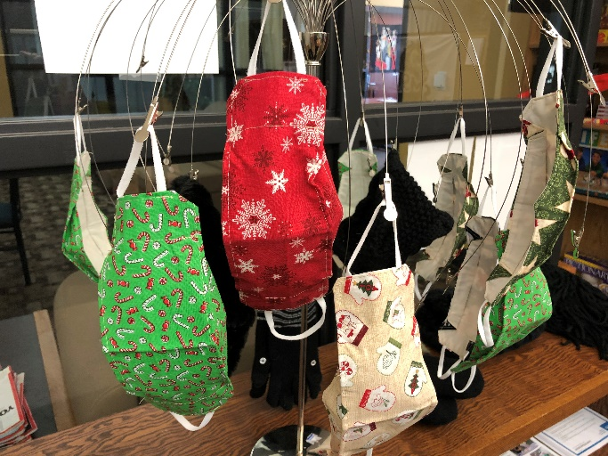

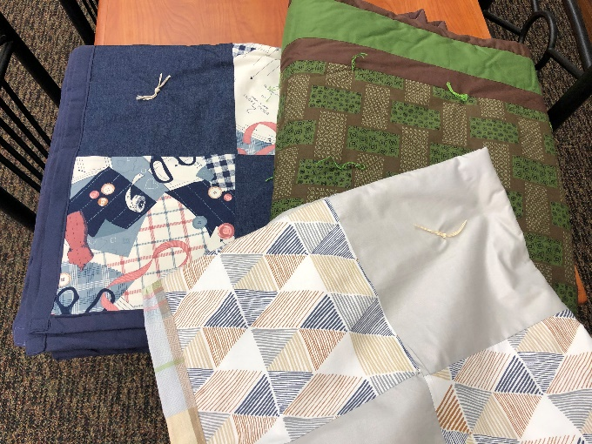

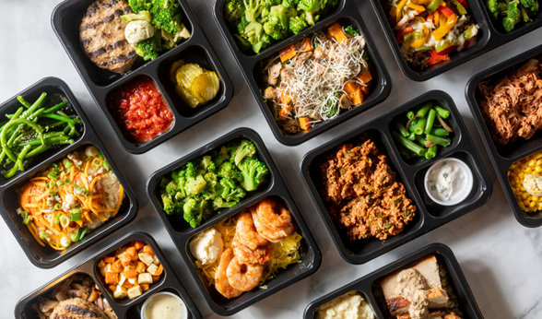**FREE Hot Meals**

Free hot meals, with a balance of proteins, carbohydrates and spices to taste great.

**Meal Pick-Ip Details**: LSS Meals, a service of Lutheran Social Services of Minnesota, will provide meals using proper masks and gloves and follow state social distancing guidelines.

**Date:** THURSDAY,DECEMBER 17 **Time:** 4:00- 5:00PM

**Location:** Holy Reedemer Church Parking lot, due to traffic cars are to line up on North 5th street no more than 15 minutes prior to distribution.

Questions contact, Lisa Gillund, LSS Meals **(507) 829-1422.**

**FREE COVID Testing**

* **Free COVID-19 saliva test kits** are available from Student Health Services in BA Rm 158, Monday-Friday 9:00AM to 4:00PM.
* **Free testing available through the Hy-Vee Pharmacy** by completing a pre-registration at doineedacovid19test.com.
* **Download the free**[**COVIDaware MN**](https://covidawaremn.com/)**app** to get notified if you have been near someone who tests positive for COVID-19.

**Next issue:**  See You Next Year - January, 2021!cid:image008.png@01D67FC4.6416C620

A publication of SMSU [Center for International Education](https://nam02.safelinks.protection.outlook.com/?url=https%3A%2F%2Fwww.smsu.edu%2Fadmission%2Finternational%2Findex.html&data=02%7C01%7Cmaylee.moua-vue%40smsu.edu%7C1ae8d17f27bb41c4d0e608d84e0571c9%7C5011c7c60ab446ab9ef4fae74a921a7f%7C0%7C0%7C637345132620472879&sdata=RsjiEO9uGrxKmxNMSyXgpDj9netDuA0OJ%2Fdh7KJJ%2Bbo%3D&reserved=0)

Student Center, Room 237 | [1501 State Street, Marshall, MN 56258](webextlink://1501%20State%20Street,%20Marshall,%20MN%2056258/)

**CENTER FOR INTERNATIONAL EDUCATION**

**OFFICE HOURS**

Mondays - Fridays, 8:30am - 4:30pm

Walk-In Advising available Mondays - Thursdays, 12:00pm-4:00pm.

Call, Email, or Visit during our Office Hours.

Phone:  (507) 537-6018

Email:  [CIE@smsu.edu](mailto:CIE@smsu.edu)

