SMSU Center for International Education (CIE)   
***Global Express***Vol 02 Issue 09 | ***January 20, 2021***

cid:image004.png@01D67FC4.6416C620

* **Welcome Back!**
* **Recap of MISO- Ice Skating**
* **FREE Blankets/Masks/Scarves & Gloves**
* **ISO Opportunities**
* **Mustangs Meetup - Coffee & Careers**
* **Apply for OPT**
* **Free Groceries**
* **HEALTH: Free COVID Testing**

**Welcome Back!**

Hope you all had a great first week. The CIE wishes you a Happy New Year ahead and best wishes for this Spring Semester! **☺**

**Recap of MISO - Ice Skating**

At the Mandatory International Student Orientation (MISO), we welcomed 26 new international students from 7 different countries this Spring 2021 semester from Ethiopia, Brazil, Nigeria, Bangladesh, Germany, and Argentina. And, we are happy to welcome back two students returning from abroad.

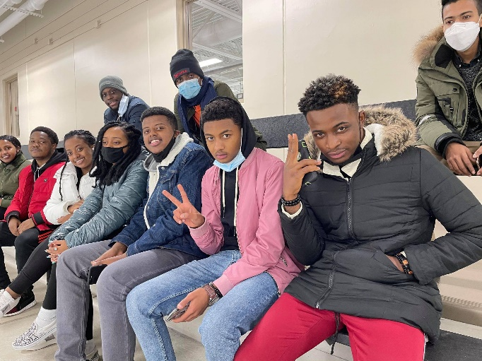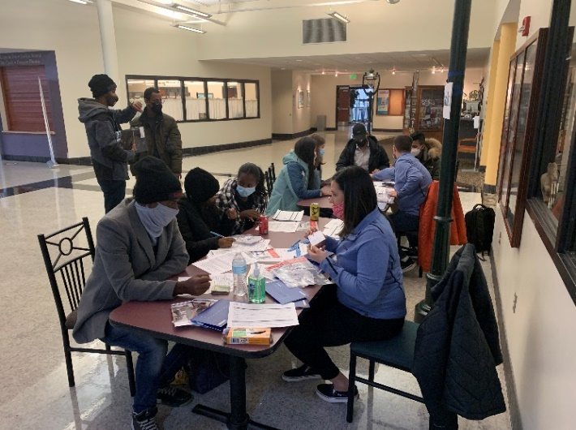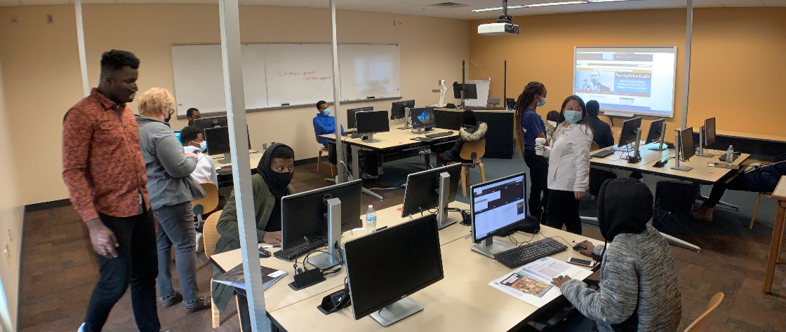

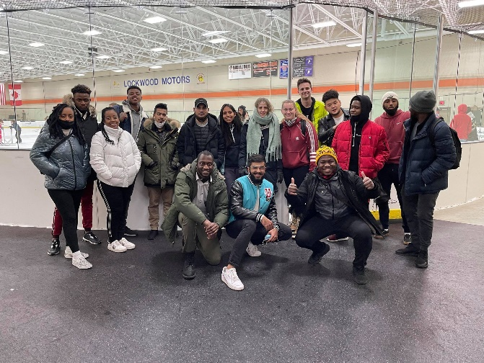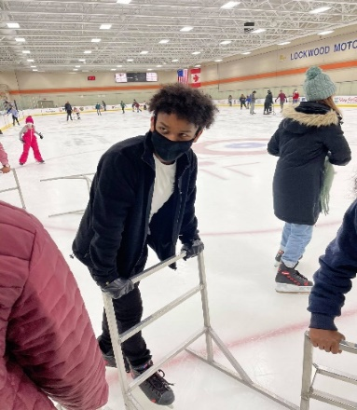

**FREE Blankets, Mask, Winter Scarves & Gloves**

Stop by the CIE office and pick up beautiful homemade blankets, gloves/scarves, and homemade holiday face masks (sewn by our very own Marilee Thompson in the Deans Office). First come first serve. ☺

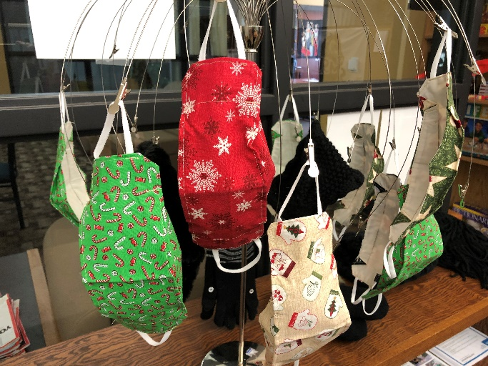

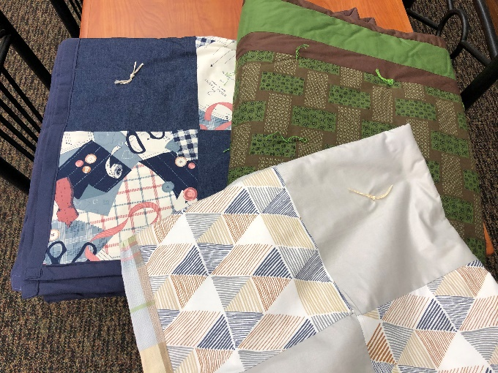

**ISO Opportunities**

**International Student Organization (ISO) is also looking for new members this semester** for new ideas and opportunities for club activities in this time of COVID. We want your feedback! Don’t hesitate to send us your thoughts and ideas. [Join ISO Club](https://nam02.safelinks.protection.outlook.com/?url=https%3A%2F%2Fsouthwestmsu.campuslabs.com%2Fengage%2Forganization%2Finternationalstudentorganization&data=02%7C01%7Cmaylee.moua-vue%40smsu.edu%7C1ae8d17f27bb41c4d0e608d84e0571c9%7C5011c7c60ab446ab9ef4fae74a921a7f%7C0%7C0%7C637345132620452890&sdata=niPjdiajS6lHZbsUAeSeiUG8AvVyyAE1Pg8C5H77l7Q%3D&reserved=0)

[**Mustangs Meetup: Coffee & Career**](https://nam02.safelinks.protection.outlook.com/?url=https%3A%2F%2Fwww.smsu.edu%2Fcampuslife%2Fcareerservices%2Fstudents-alumni%2Fon-campus-events.html&data=04%7C01%7Cmaylee.moua-vue%40smsu.edu%7C52a9442b26d24e4ee67708d8bccd8267%7C5011c7c60ab446ab9ef4fae74a921a7f%7C0%7C0%7C637466938866395750%7CUnknown%7CTWFpbGZsb3d8eyJWIjoiMC4wLjAwMDAiLCJQIjoiV2luMzIiLCJBTiI6Ik1haWwiLCJXVCI6Mn0%3D%7C1000&sdata=qaAMPGsDrkq9ortjaHqiQP77Opkclpjfe0RBMhv%2BlQk%3D&reserved=0)**s**

[**Mustangs Meetup: Coffee & Careers**](https://nam02.safelinks.protection.outlook.com/?url=https%3A%2F%2Fwww.smsu.edu%2Fcampuslife%2Fcareerservices%2Fstudents-alumni%2Fon-campus-events.html&data=04%7C01%7Cmaylee.moua-vue%40smsu.edu%7C52a9442b26d24e4ee67708d8bccd8267%7C5011c7c60ab446ab9ef4fae74a921a7f%7C0%7C0%7C637466938866395750%7CUnknown%7CTWFpbGZsb3d8eyJWIjoiMC4wLjAwMDAiLCJQIjoiV2luMzIiLCJBTiI6Ik1haWwiLCJXVCI6Mn0%3D%7C1000&sdata=qaAMPGsDrkq9ortjaHqiQP77Opkclpjfe0RBMhv%2BlQk%3D&reserved=0) will be held **Tuesday, February 9, 2021**.  This is a career fair held virtually on Handshake from **11:00 a.m. - 2:00 p.m.**  Employers will be highlighting their organization's current/future opportunities for internships or full-time positions.  This career fair will offer virtual 1-on-1 and group sessions.  All majors are welcome to attend!  For a growing list of attending employers, visit [https://www.smsu.edu/campuslife/careerservices/students-alumni/on-campus-events.html](https://nam02.safelinks.protection.outlook.com/?url=https%3A%2F%2Fwww.smsu.edu%2Fcampuslife%2Fcareerservices%2Fstudents-alumni%2Fon-campus-events.html&data=04%7C01%7Cmaylee.moua-vue%40smsu.edu%7C52a9442b26d24e4ee67708d8bccd8267%7C5011c7c60ab446ab9ef4fae74a921a7f%7C0%7C0%7C637466938866405742%7CUnknown%7CTWFpbGZsb3d8eyJWIjoiMC4wLjAwMDAiLCJQIjoiV2luMzIiLCJBTiI6Ik1haWwiLCJXVCI6Mn0%3D%7C1000&sdata=fid1k5K4D0US%2F0BE5Uw97qyncu8BTPXCEj1IS8EUebQ%3D&reserved=0) or Log in to [Handshake](https://nam02.safelinks.protection.outlook.com/?url=https%3A%2F%2Fsmsu.joinhandshake.com%2Flogin%3Frequested_authentication_method%3Dstandard&data=04%7C01%7Cmaylee.moua-vue%40smsu.edu%7C52a9442b26d24e4ee67708d8bccd8267%7C5011c7c60ab446ab9ef4fae74a921a7f%7C0%7C0%7C637466938866405742%7CUnknown%7CTWFpbGZsb3d8eyJWIjoiMC4wLjAwMDAiLCJQIjoiV2luMzIiLCJBTiI6Ik1haWwiLCJXVCI6Mn0%3D%7C1000&sdata=Esg5tPRWO%2FlPqZTjP3oaEdb5oh%2BsJhTehynqA2Qx9jM%3D&reserved=0) to learn more about the employers and register for 1:1 or group sessions.

**Are you Graduating this May? Apply for OPT Now**

Optional Practical Training (OPT) allows you to work anywhere in the U.S. in a job *related* to your major field of study *after* you graduate. This workshop is mandatory before you can apply. The application approval process takes 3-5 months. OPT fee is $550.

**Zoom OPT Workshop - FRI | Feb 12 | 3:00 – 4:30pm**

Register to Receive the Zoom information:

<https://minnstate.zoom.us/meeting/register/tJcpd-iurD8jGtKOpfG4oC4VKoDuO1QJJf89>

**Free Groceries**

Wednesday, January 20th- schedule pick up time at Bellows Academic 161, Center for Civic and Community Engagement. [**bit.ly/MustangMarketAppointment**](https://nam02.safelinks.protection.outlook.com/?url=https%3A%2F%2Fbit.ly%2FMustangMarketAppointment&data=04%7C01%7CKamal.West.2%40smsu.edu%7Cf2e3969726c14d6b008208d8b8e83979%7C5011c7c60ab446ab9ef4fae74a921a7f%7C0%7C0%7C637462654822153258%7CUnknown%7CTWFpbGZsb3d8eyJWIjoiMC4wLjAwMDAiLCJQIjoiV2luMzIiLCJBTiI6Ik1haWwiLCJXVCI6Mn0%3D%7C1000&sdata=tKlQTQmdrgr0XwL7zK8gE8q69C7AFFO7Q23kYaYo0kw%3D&reserved=0)**.** For information, please contact[civic.engagment@smsu.edu](mailto:civic.engagment@smsu.edu)

**H E A L T H**

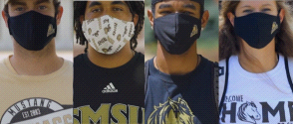

**SMSU Mask Policy & COVID Self-Assessment**

Southwest Minnesota State students are required to wear masks on campus. This is for everyone's safety as COVID is alarmingly contagious. Don't forget to fill out the COVID-19 Self-Assessment forms daily: [https://mnscu.co1.qualtrics.com/jfe/form/SV_0oA2XakMFIL284Z](https://nam02.safelinks.protection.outlook.com/?url=https%3A%2F%2Fmnscu.co1.qualtrics.com%2Fjfe%2Fform%2FSV_0oA2XakMFIL284Z&data=02%7C01%7Cmaylee.moua-vue%40smsu.edu%7C1ae8d17f27bb41c4d0e608d84e0571c9%7C5011c7c60ab446ab9ef4fae74a921a7f%7C0%7C0%7C637345132620462884&sdata=UGikqNOb%2FDVOtyE7728x%2FQZvmLp%2B4k7ScfWIdrdMDU8%3D&reserved=0)

**FREE COVID Testing**

* **Free testing available through the Hy-Vee Pharmacy** by completing a pre-registration at doineedacovid19test.com.
* **Download the free**[**COVIDaware MN**](https://covidawaremn.com/)**app** to get notified if you have been near someone who tests positive for COVID-19.

cid:image004.png@01D67FC4.6416C620

**Next issue:** Volume 2 Issue 10 will arrive February 2nd we wish you all the best in your academic endeavors.

Image

A publication of the SMSU [Center for International Education](https://nam02.safelinks.protection.outlook.com/?url=https%3A%2F%2Fwww.smsu.edu%2Fadmission%2Finternational%2Findex.html&data=02%7C01%7Cmaylee.moua-vue%40smsu.edu%7C1ae8d17f27bb41c4d0e608d84e0571c9%7C5011c7c60ab446ab9ef4fae74a921a7f%7C0%7C0%7C637345132620472879&sdata=RsjiEO9uGrxKmxNMSyXgpDj9netDuA0OJ%2Fdh7KJJ%2Bbo%3D&reserved=0)

Student Center, Room 237  
[1501 State Street, Marshall, MN 56258](webextlink://1501%20State%20Street,%20Marshall,%20MN%2056258/)

**CENTER FOR INTERNATIONAL EDUCATION**

**OFFICE HOURS**

Mondays - Fridays, 8:30am - 4:30pm

Walk-In Advising available Mondays - Thursdays, 12:00pm-4:00pm.

Visit, Call, or Email us during our Office Hours.

Phone:  (507) 537-6018

Email:  [CIE@smsu.edu](mailto:CIE@smsu.edu)

