Safety Committee Meeting Minutes Date: 6.4.25

**Present: David Hemp, Tony Nubile, Pam Martinson, Joe Krogman, Brad Besse**

**Injury Update:**

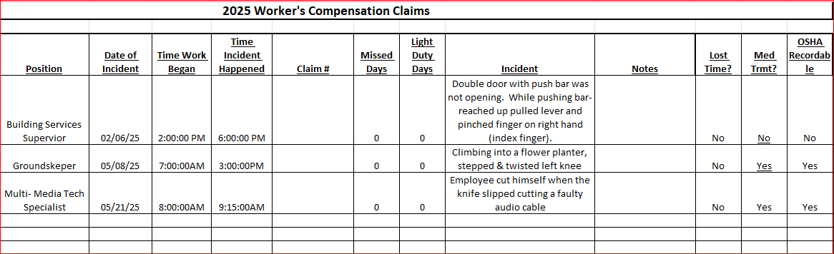

**Drills:** Evacuation drill cancelled – scheduling.

**Inspections:** Fire alarm systems were inspected two weeks ago, everything was good!

**Dave’s report:** - Attended Minnesota Safety Conference early May

* MN Safety Director’s mtg Jun 10-11, St. Cloud.
* Mercury Reduction from City of Marshall. Last in 2015; mercury thermometers
* Updating OSHA Programs
* Fire pit usage – do we need a procedure after scheduling?
* Weather watch notification feedback
* Veolia contacted for Haz Waste pickup
* Museum pickup
* Reminder: Outside work near traffic – safety vests required

**Round Robin:**

Joe: Nothing to report

Brad: Nothing to report

Pam: AED Training Video

Tony: RFP for AC repair in Bellows is in process – asbestos abatement will be an issue

Conference Center Elevator is in need of being rebuilt, in progress