Safety Committee Meeting Minutes Date 7/22/2024

**Present:** Dave Hemp, Joe Krogman, Pat Daniels, Brad Besse, Pam Martinson, Tim Schrunk

**Injury Update:** One new - Highlighted

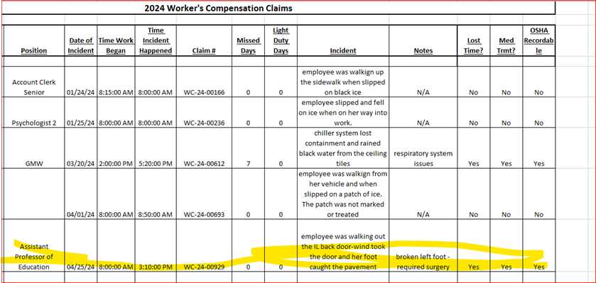

**Drills:** None to report

**Inspections:** Upcoming system visit – haven’t heard back exactly when they are coming; Pat - all Life Safety alarms have been inspected; Tim - Ansul fire suppression system was inspected, Fire Extinguisher inspections are August 5-9.

**Dave’s report:**

* Upcoming Hazardous Waste pickup
* Open fire extinguisher training 8/21 at 10am in BA 101
* New Cameras – only added to academic buildings, discussion was had regarding cameras in the hallways of the residence halls as there was significant damage to Sweetland hall exit signs this past spring
* AED Training: Please review: <https://www.zoll.com/contact/elearning/videos/aed-plus#lightbox-81ca67a7-a122-40d3-bed3-e5ea93040426>

**Round Robin:**

Joe: Nothing to report

Pam: Nothing to report

Brad: Nothing to report

Tim: Dryer vents have been inspected and cleaned

Pat: Concern with the ladder procedure currently used to change light bulbs in BA 101. Currently a “Little Giant” ladder system is being used with 4 GMW’s holding the ladder for one to climb. This practice seems to be unsafe.

**Response**: Mr. Hemp researched and found a mobile flexible scaffold system that can be used to safely changed: [https://lightbulbscaffold.com/](https://nam02.safelinks.protection.outlook.com/?url=https%3A%2F%2Flightbulbscaffold.com%2F&data=05%7C02%7CDave.Hemp%40smsu.edu%7C379b4141ba074a56ef8a08dcaa7ed375%7C5011c7c60ab446ab9ef4fae74a921a7f%7C0%7C0%7C638572708898931762%7CUnknown%7CTWFpbGZsb3d8eyJWIjoiMC4wLjAwMDAiLCJQIjoiV2luMzIiLCJBTiI6Ik1haWwiLCJXVCI6Mn0%3D%7C0%7C%7C%7C&sdata=ZteLqQDRLdMls13B36hm0xhuLvKcLrWQotrB6q8tjg0%3D&reserved=0). Recommendation was made to Tony Nublie to use this.

Other: Fire alarm response in the SS building was discussed: according to Pat, SMSU will still monitor the alarm and will provide a response. The fire panel room will be accessible to SMSU employees but the building will have a secure area as well. Questions surround the SMSU Public Safety response. Public Safety will need to have access to check for actual fire, smoke or damage.